SabreSonic Interact
Oman Air

login in PC: wy wy
Sign in Sabre: Sign in
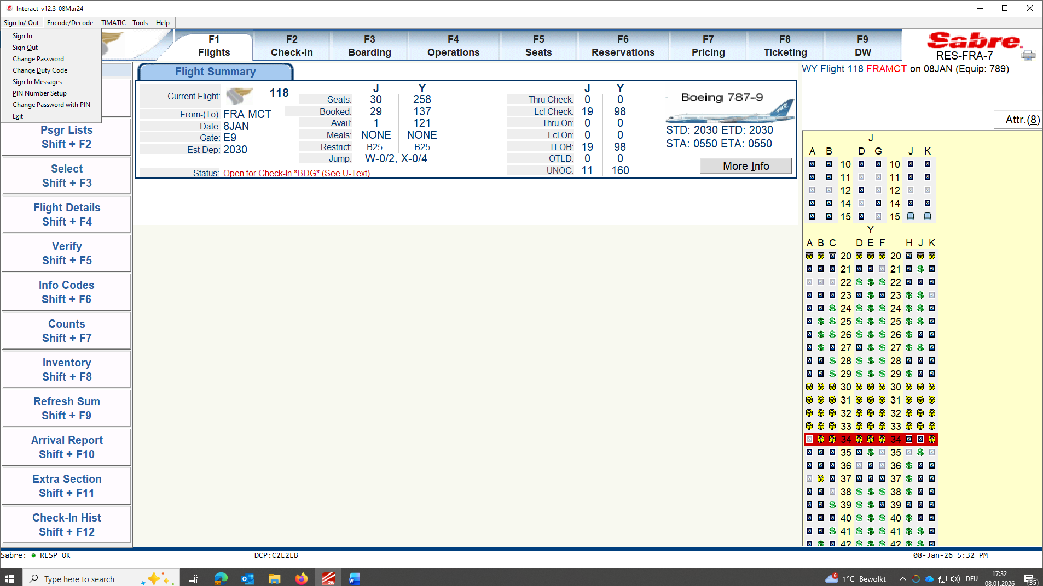

Sign-in in system:
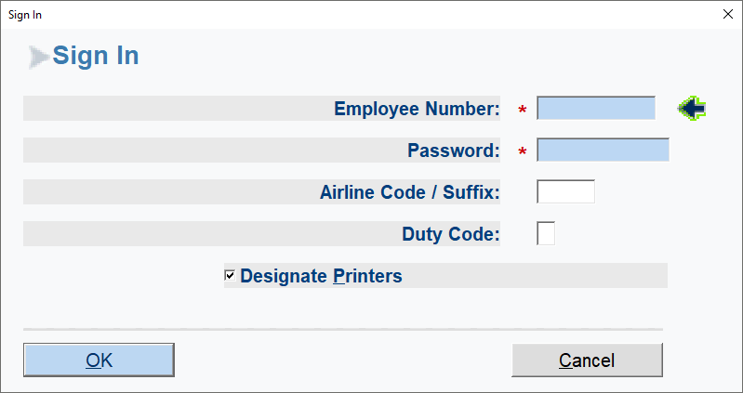

The following steps are the steps to sign-in:
- Enter Employee Number and Password.
- Enter Airline code / Suffix and duty code.

After successful sign-in, the Printer functions pop-up is displayed.
- Choose in the selection: Designate printer.
- Assign Bag Tag printer address and Boarding pass printer address.
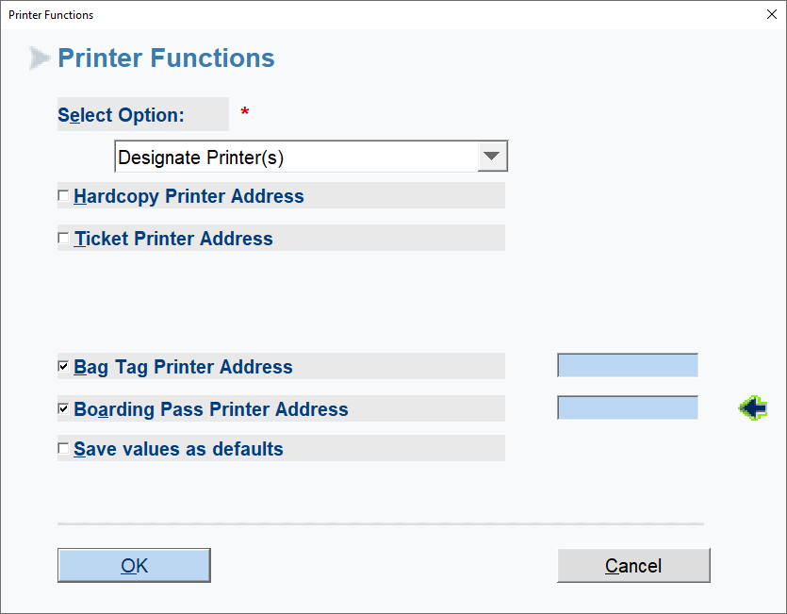

To sign-in to flight List shift +F1.
- Click on WY118/Date and OK.
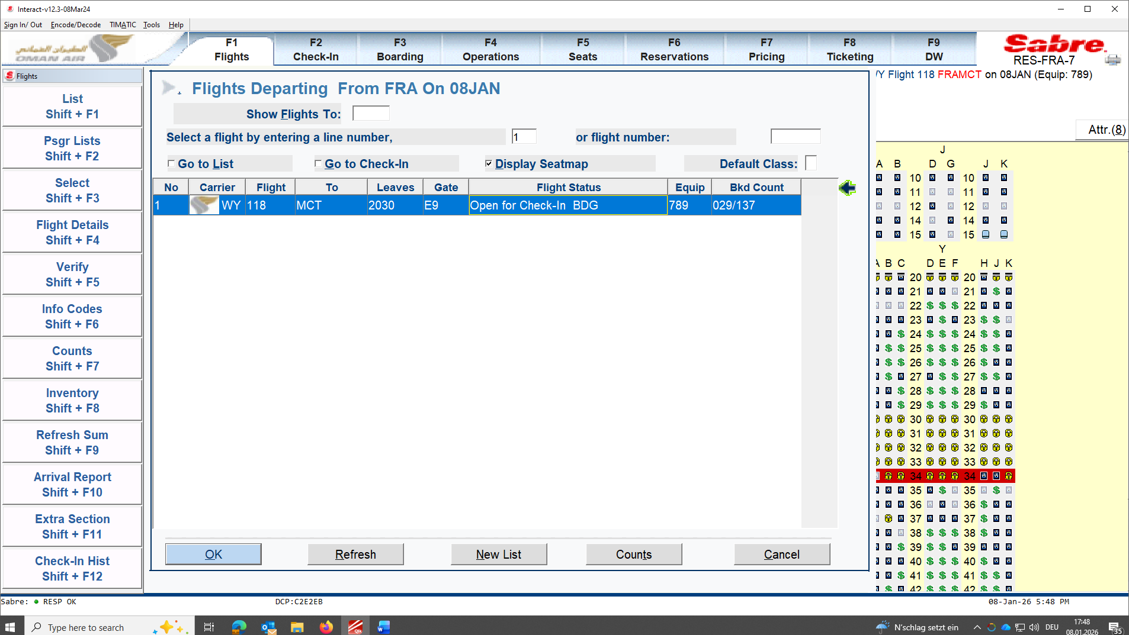

Check-in process:
Click on Psgr lists Shift + F2
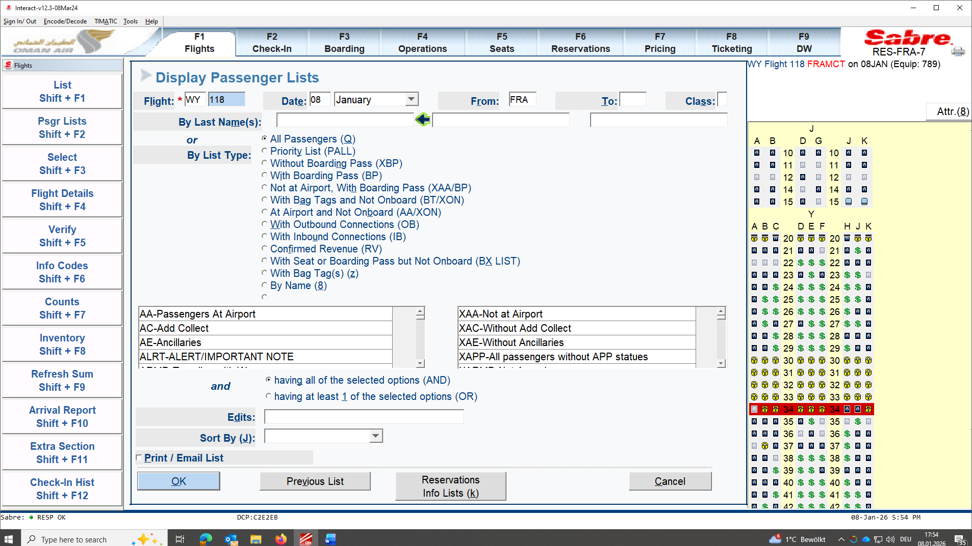

Type in by last name:
ALL GUESTS NEEDS TO HAVE ETI OR ETO (with IR and ok from WY REP BESIDE NAME)
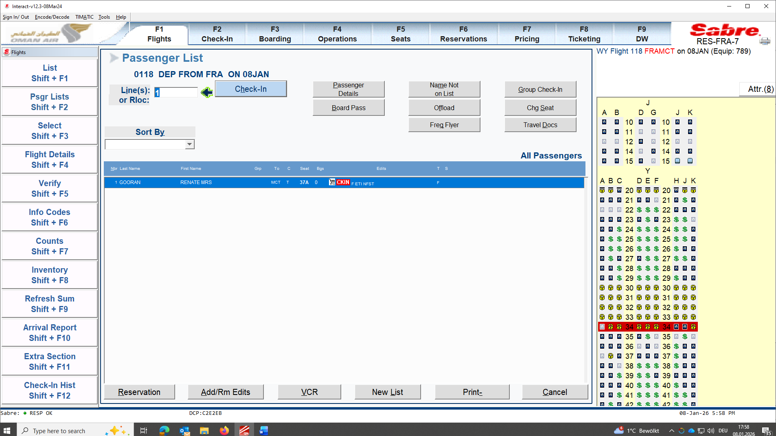
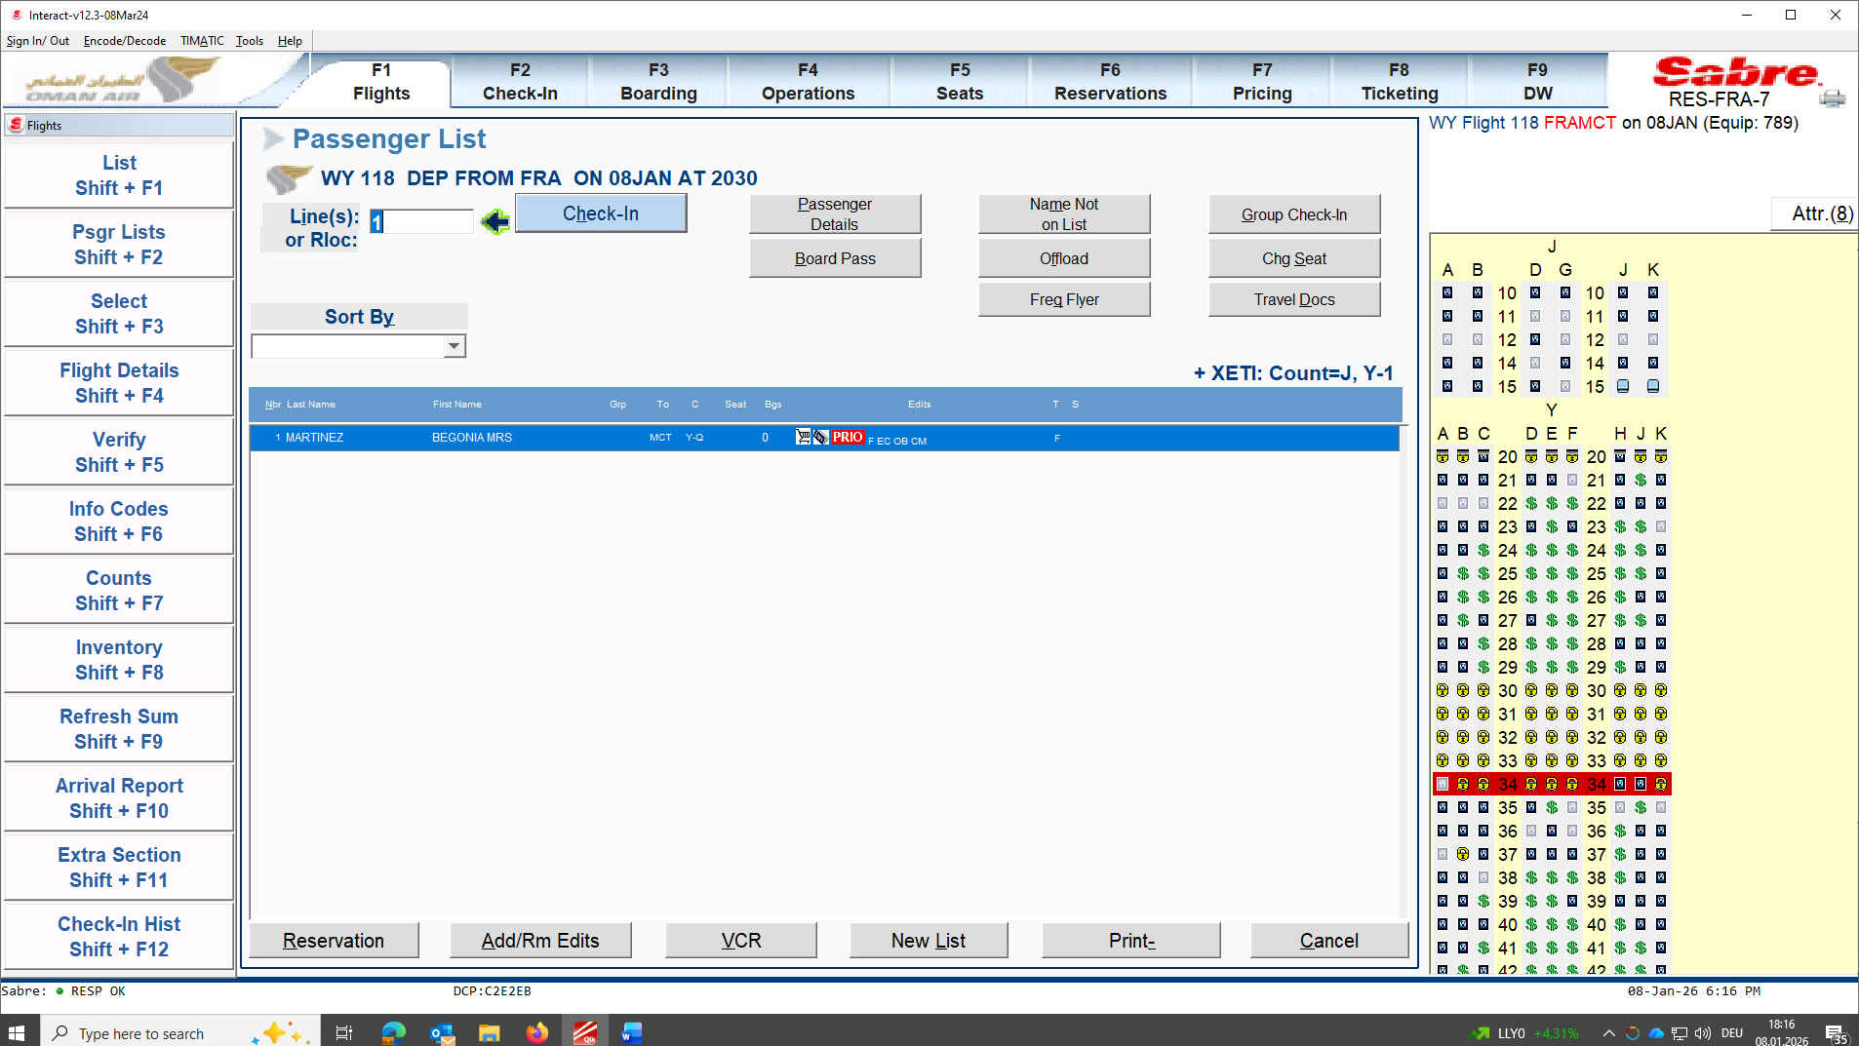

Check if passenger if flying alone or in GRP.
- If in GRP click Group Check-in.
- Check if Guest has any CM or SS ( Ex. NFST,WCHR ETC.)

- Check VCR for KGS allowance or PC concept. (Ex. NIL, 20Kgs or 30 Kgs. 1 PC Economy is 23 Kgs and 1pc Business class is 32 Kgs.)
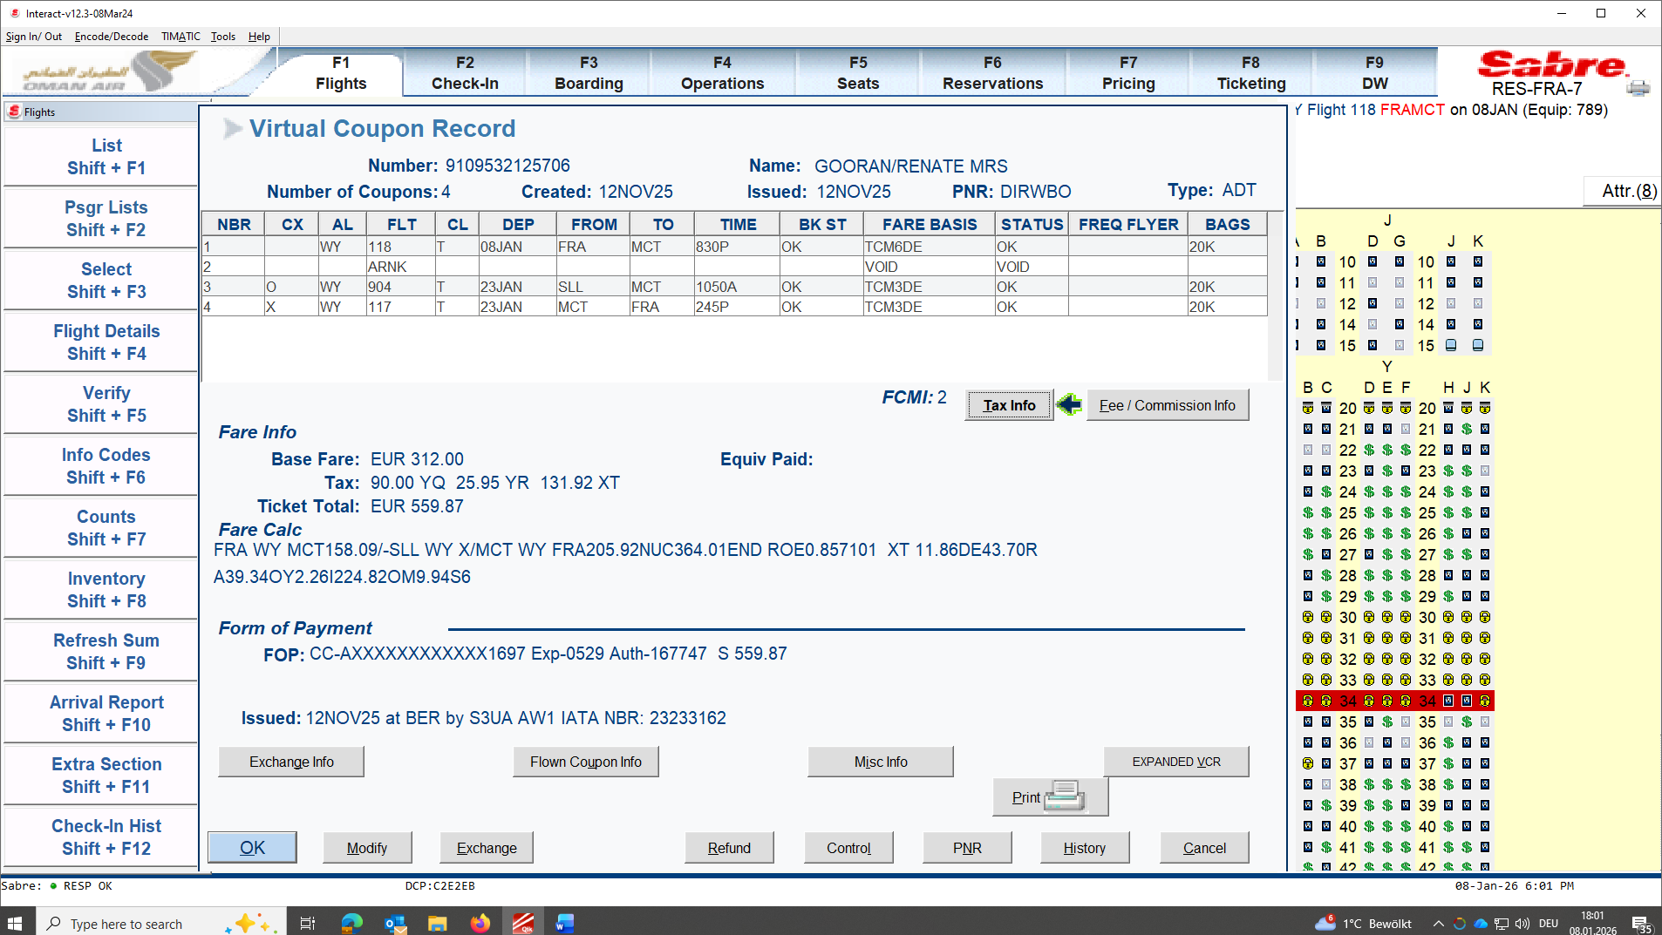
- Check TIMATIC for Visa Travel Information.
Enter Passenger Nationality and Passenger Destination.
If needed Alien Residency and City of Transit
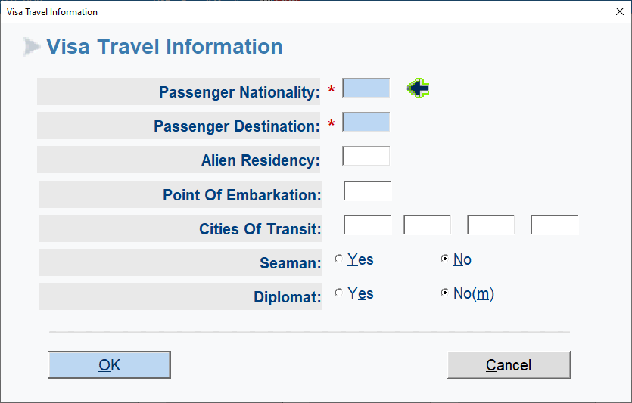

Read entire TIMATIC by manually pressing on keyboard PG UP or PG DN until SCAN COMPLETE.
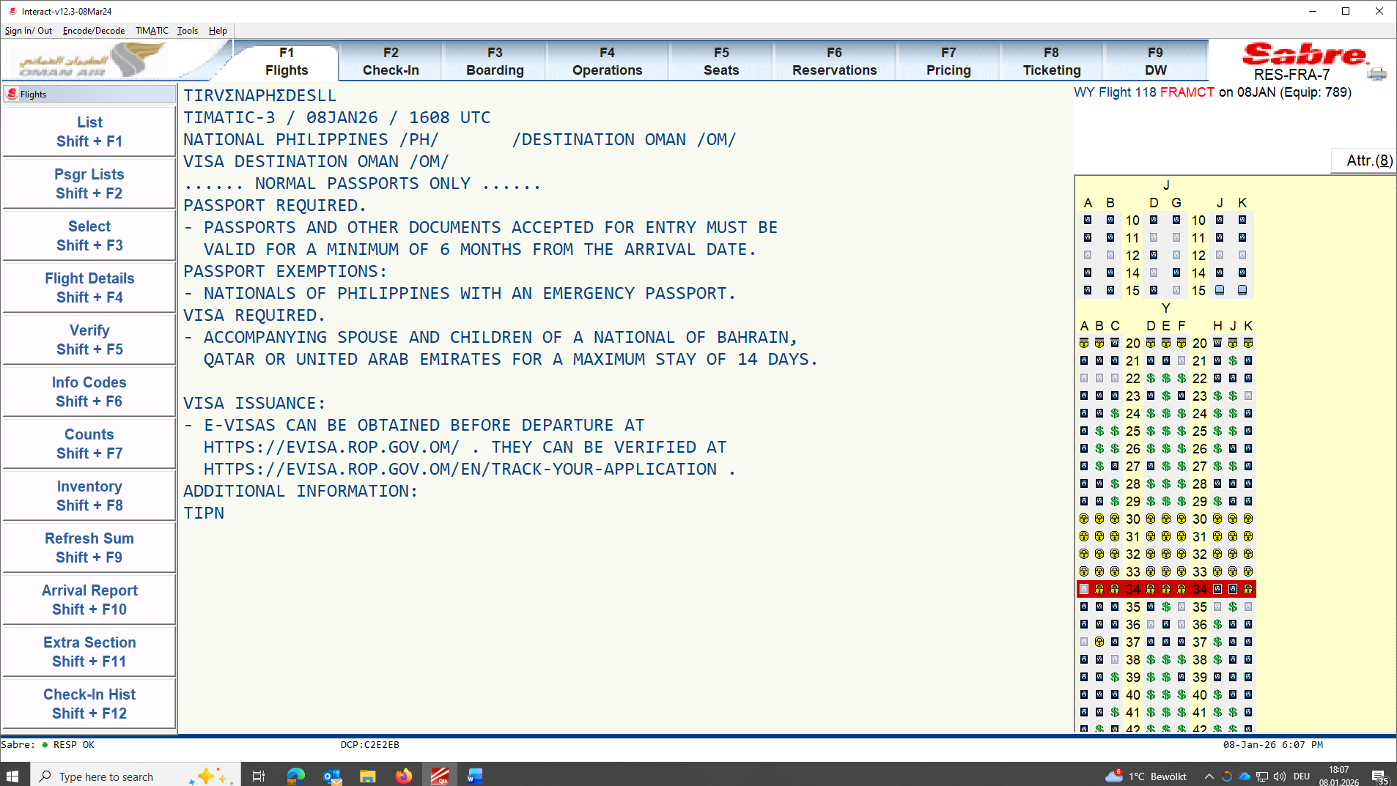

!!! ALWAYS EXIT TIMATIC !!!
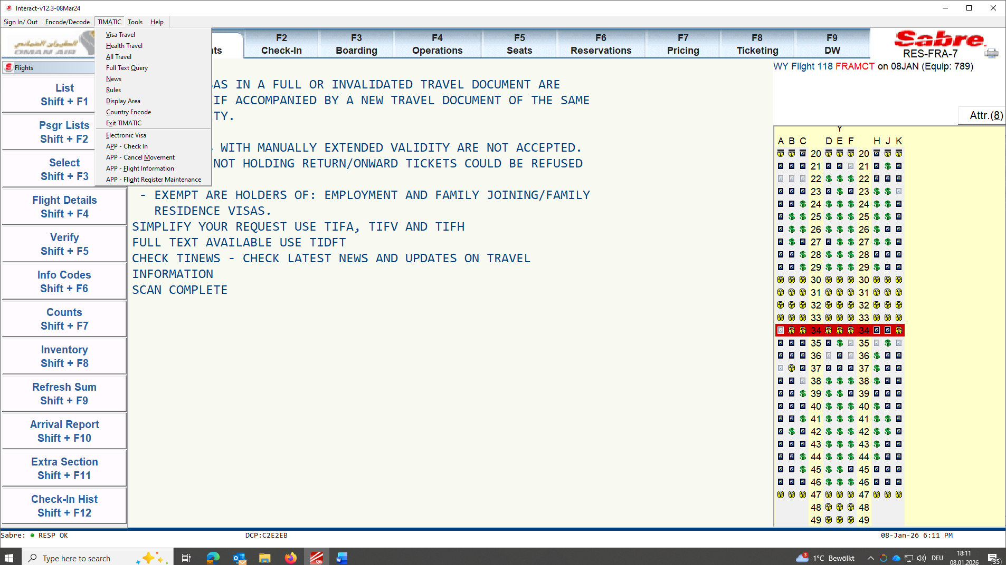
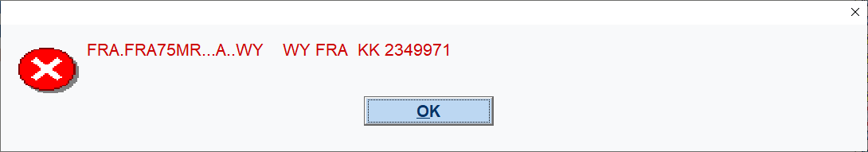
Clear window py pressing CTRL+I
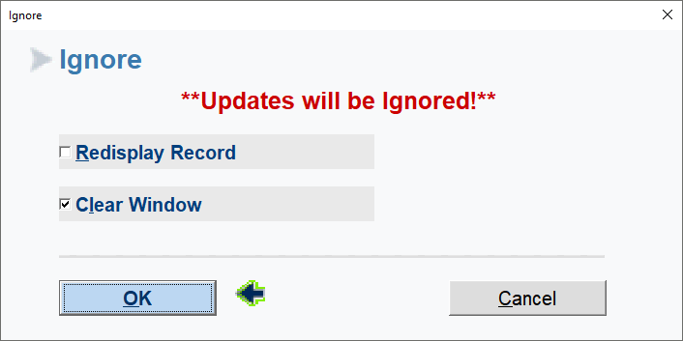

After checking all needed documents. We may continue the check-in by clicking on name ENTER
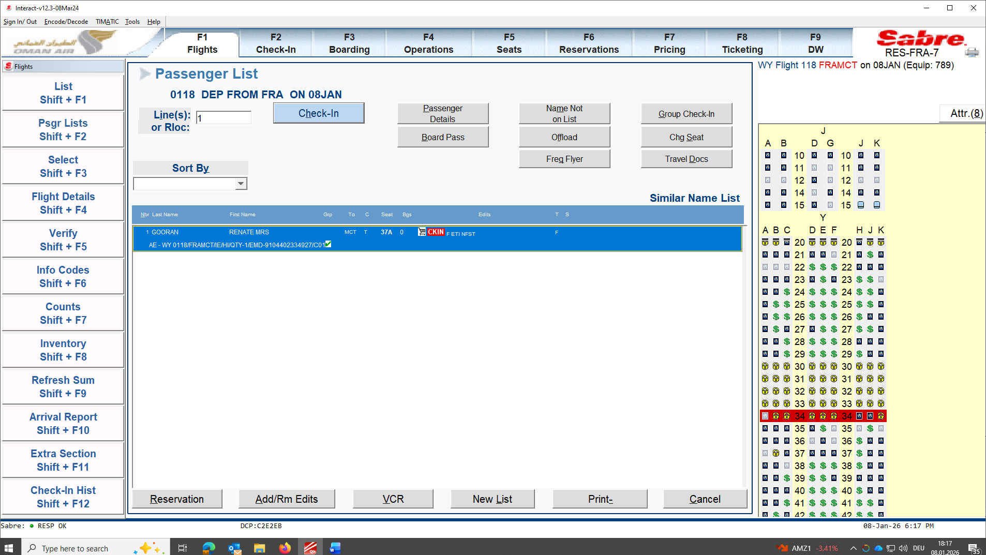

Press on TRAVEL DOCUMENTS
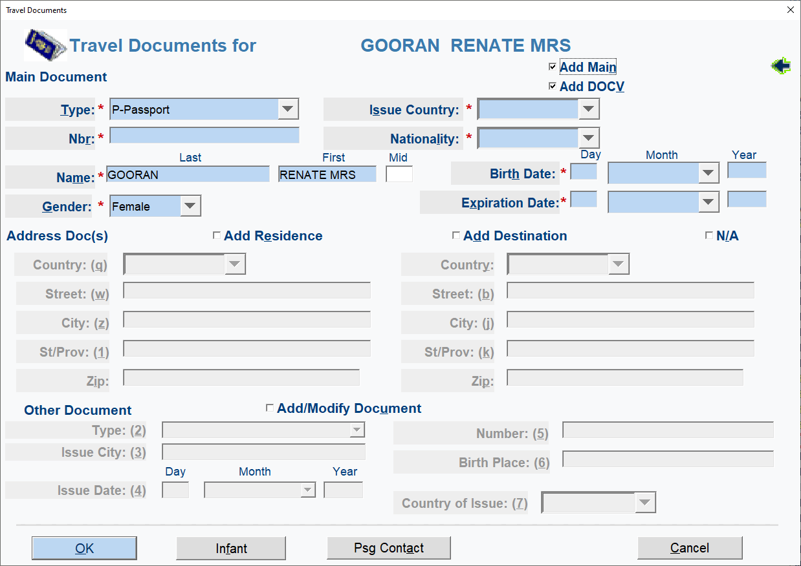
Click on Add Main and DOCV.
Swipe passport and verify if passport details are correct in system. If ok click OK.
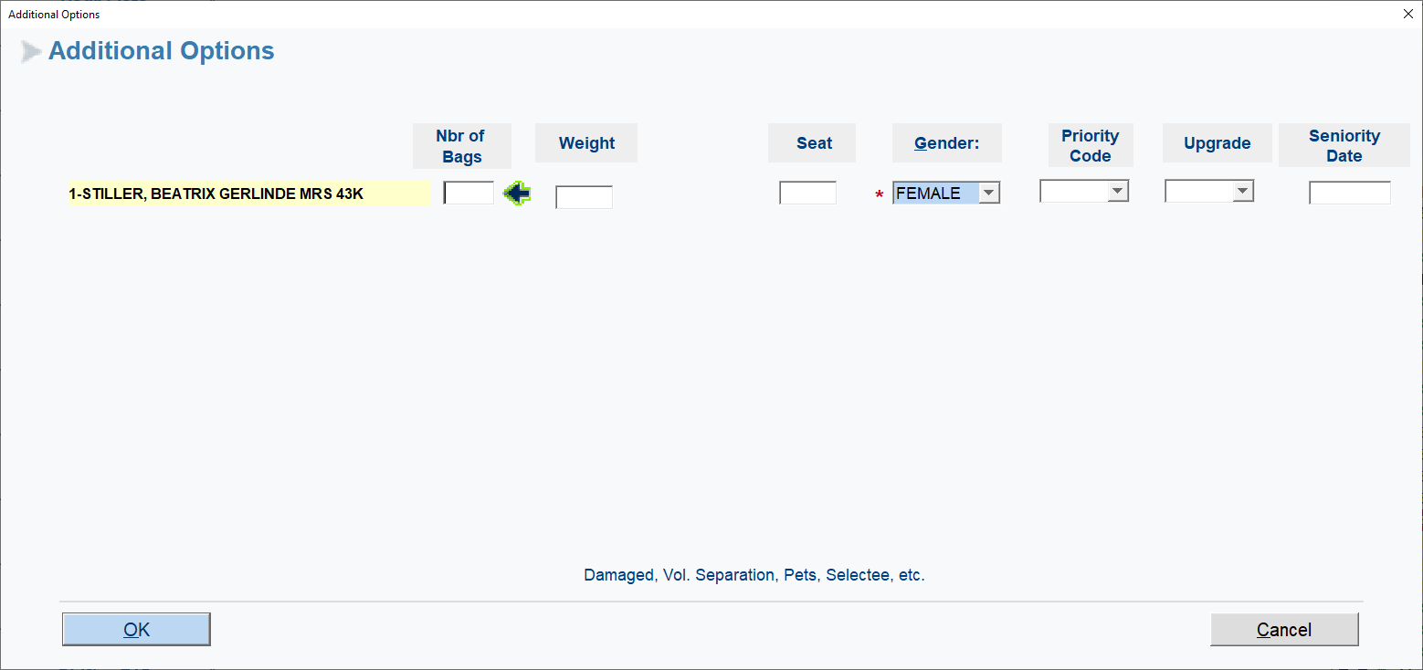
Adding bag Nbr of Bags/ Weight
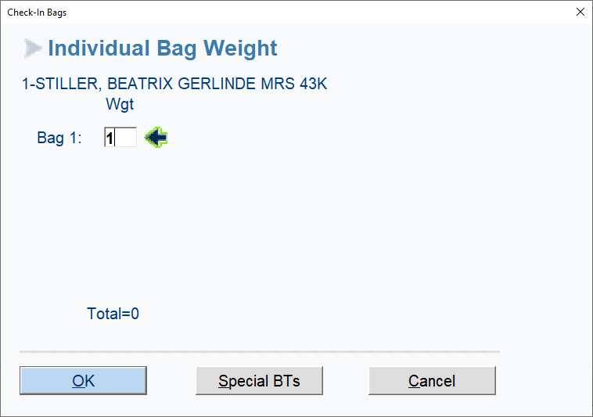

Special BTs if needed for
Limited release for WCH, ROLLATOR and Hand bag at gate if ok from REP. Guests needs to sign and acknowledge and write CM.
Others DAMAGED and CM brand of bag and what is damaged. Call WY Rep for documentation (picture). Guest needs to sign to acknowledge.
Bagpacks only needs to be signed and CM ex. Bagpack signed no liability if damaged
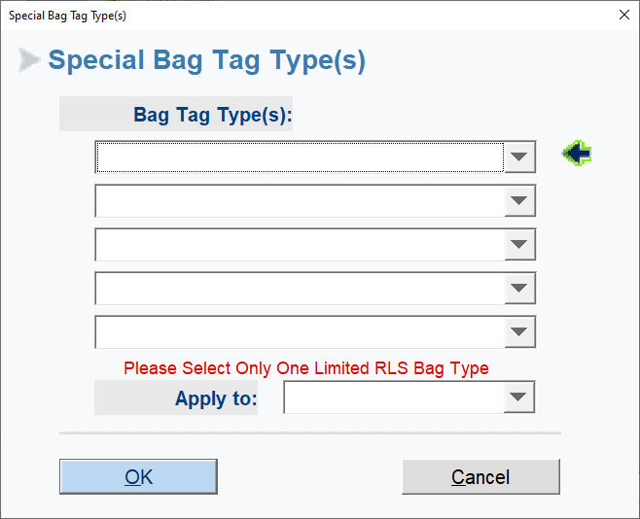
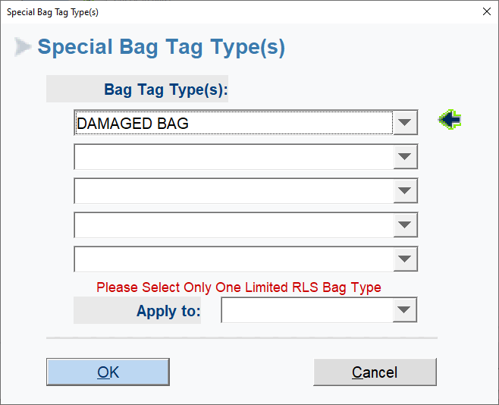

CM is located at Add/RM Edits:
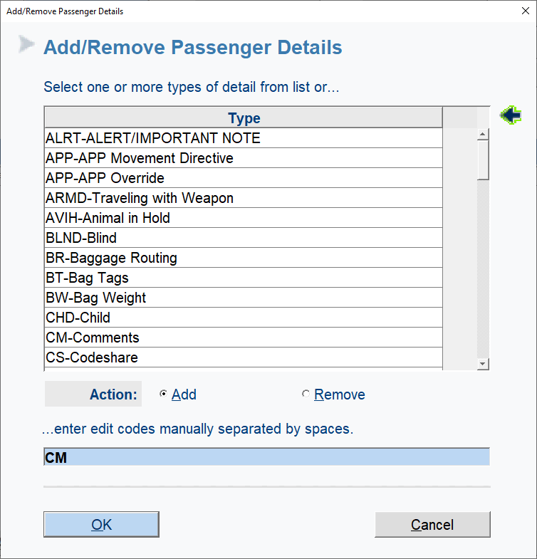
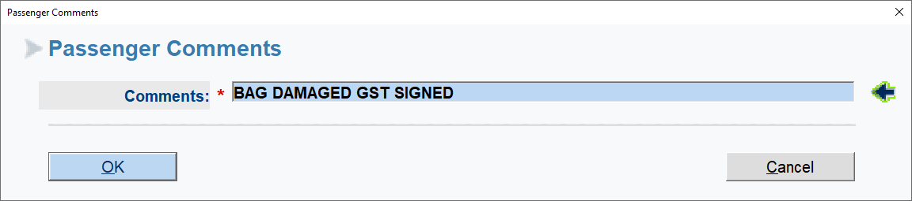

Confirm Guests with bag via Security questions: OK
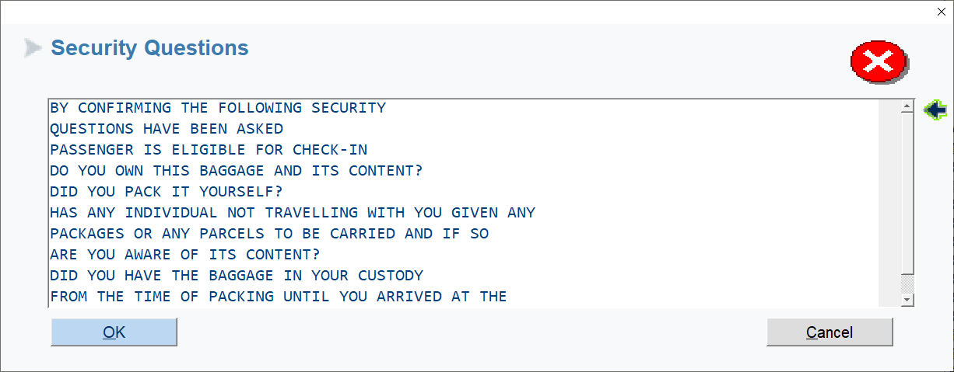
Guest is checked in:
Printing in process for Boarding card and Baggage tag
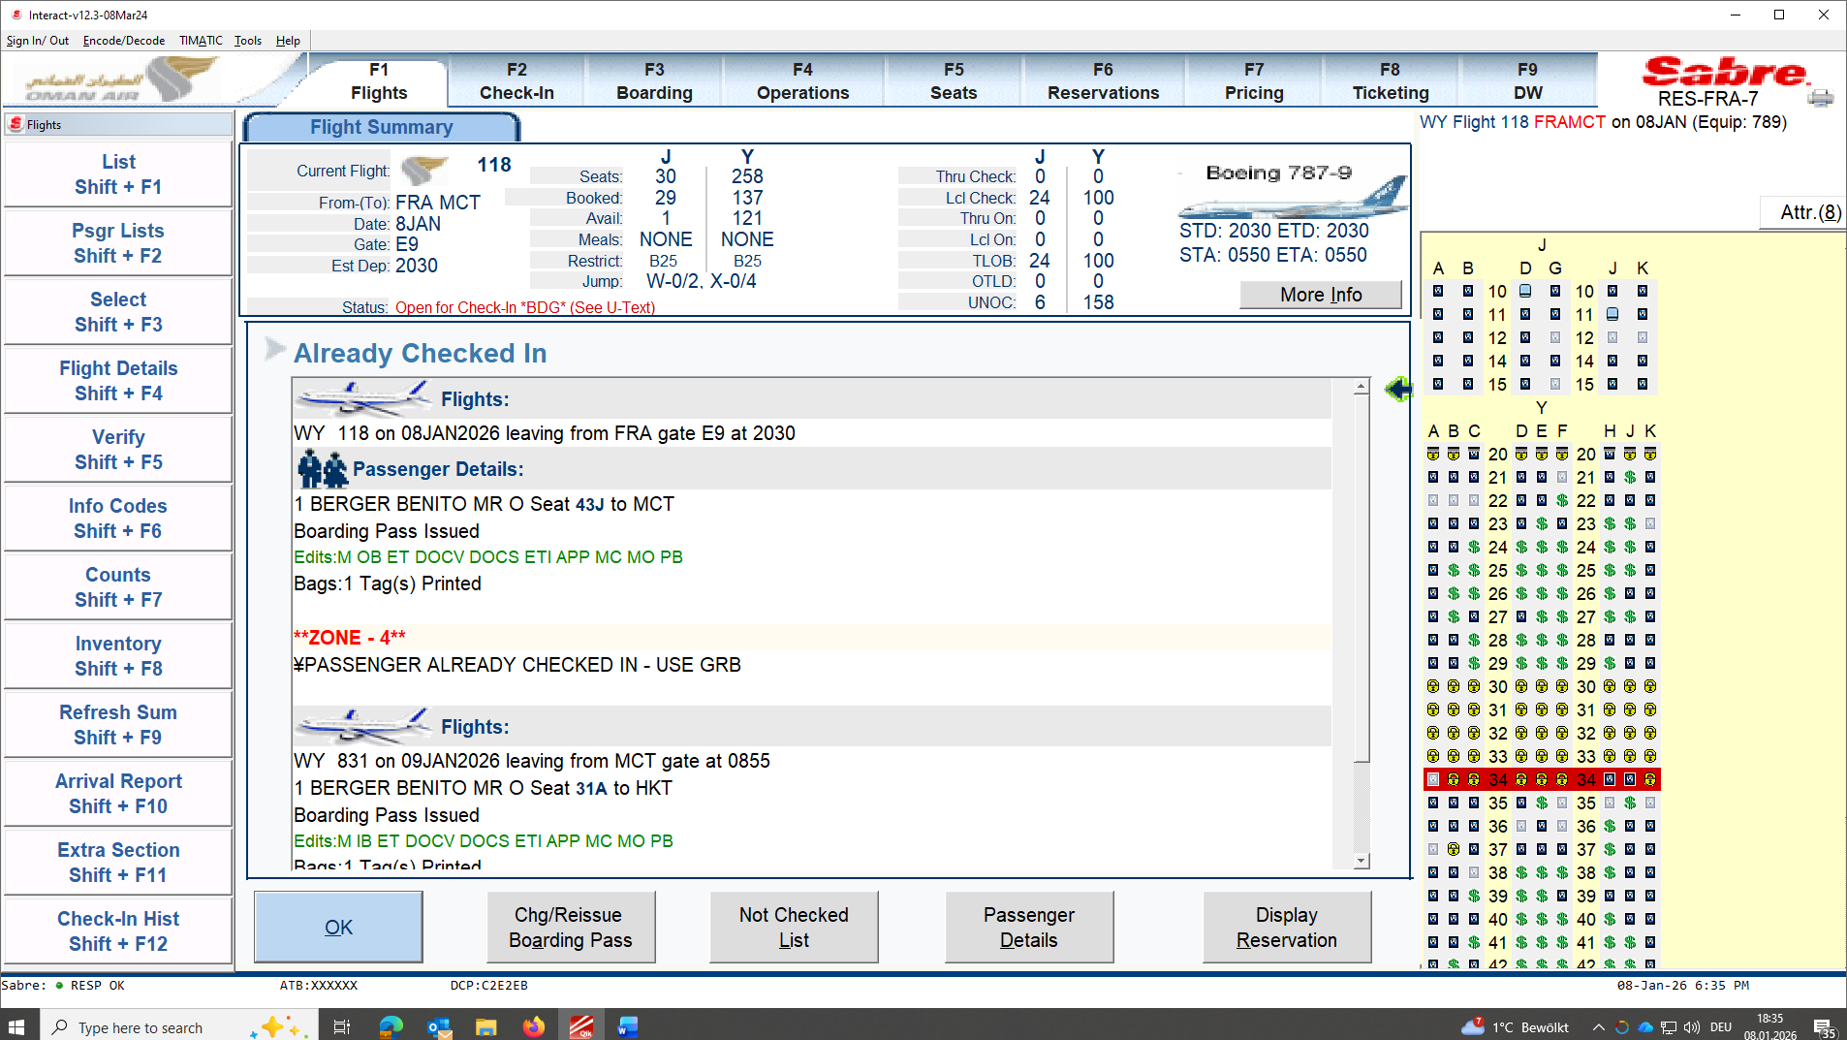

Confirm with Guest name to double check name and end destination of Boarding card and baggage tag.

MANUAL BAGTAG:
Locate Guest
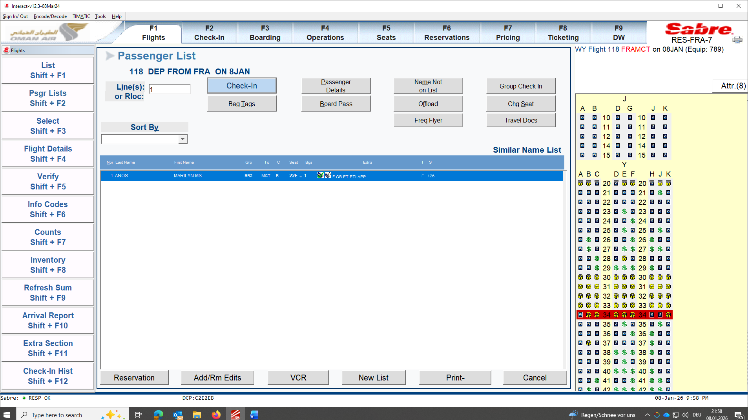
Click on BAGTAG
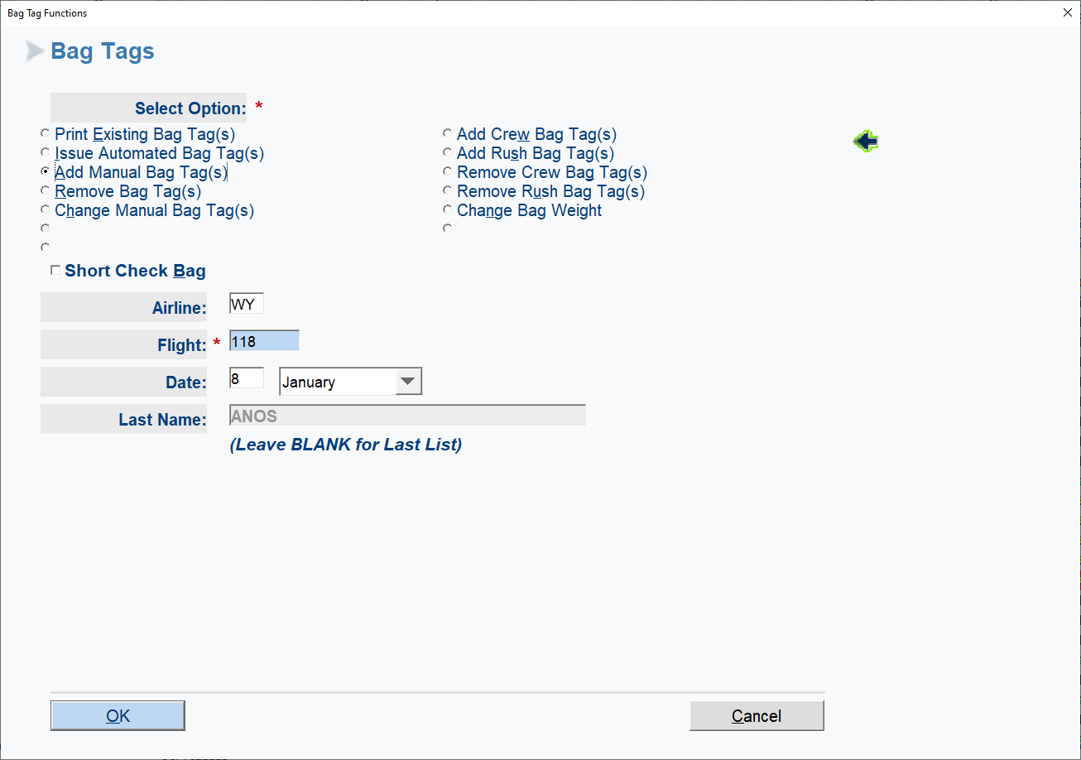

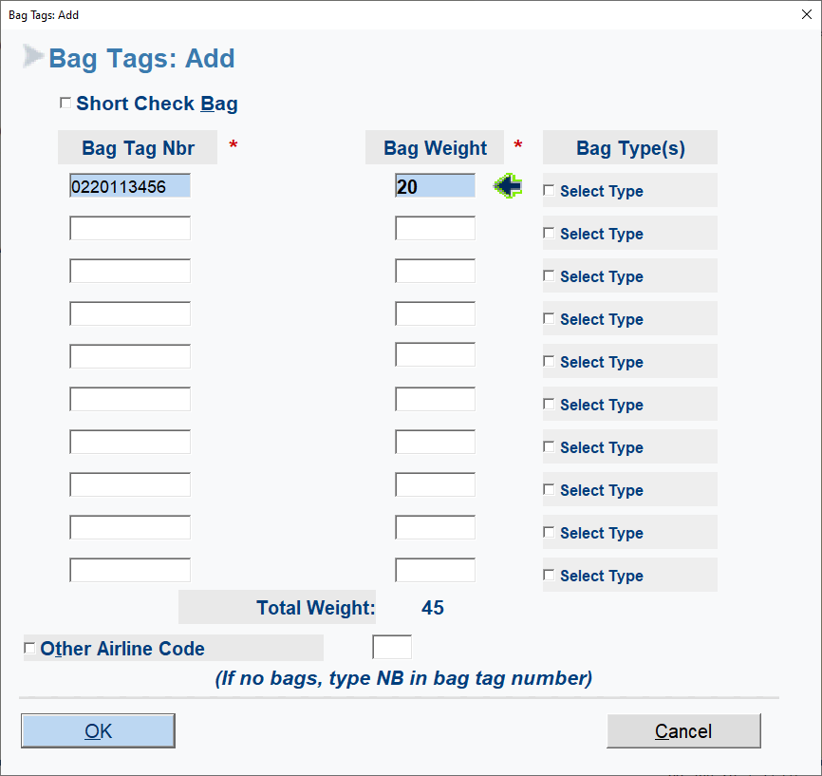
Enter all needed Documents and weight OK.

BLOCK and UNBLOCK SEATS:
Click F5.
Click on BLOCK / UNBLOCK Shift+F3 ( only done by flight controller unless told otherwise from WY REP or Flight controller.

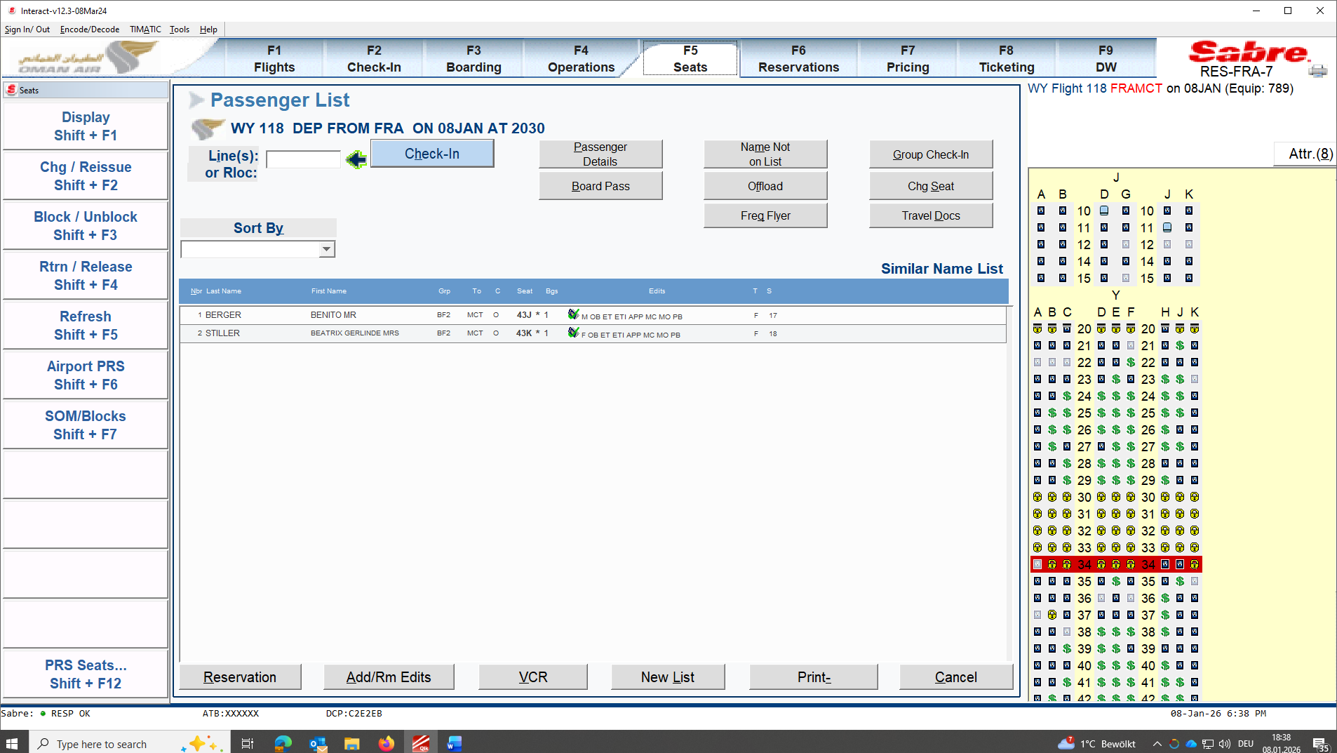

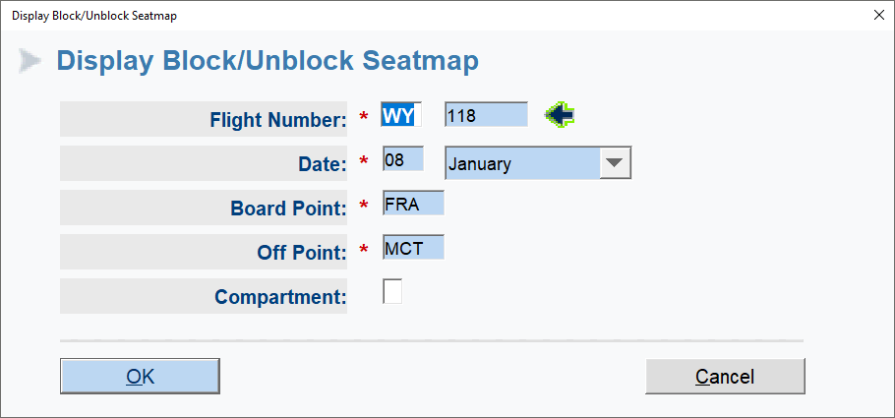
Choose seat to be blocked or unblock and ok
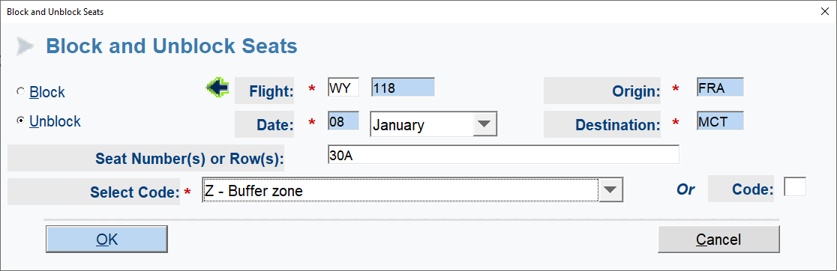

BOARDING POINT:
Same entry wy wy
Click on WY Interact
Boarding

Same sign in as at beginning

Sign in flight.
F3 for Boarding and click on Board Shift + F1
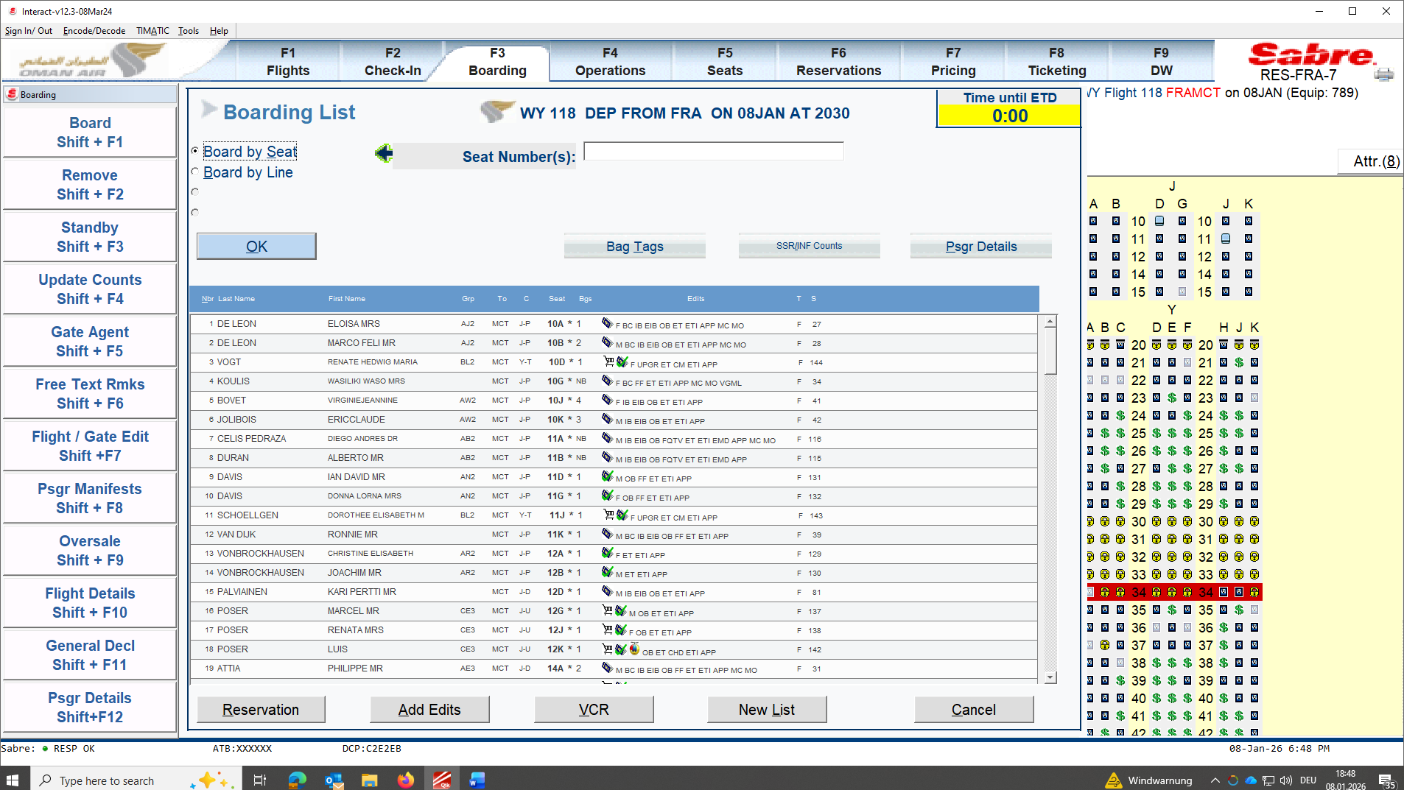

Choose 2 gate readers as we start Pre – Boarding 2 Hours prior departure.
!!! Before starting PRE-BOARDING Clear Boarding gate Area from guests, prepare Crew area/ WCH Area by closing with lining in front of Boarding gate entry.
!!! Prepare also all needed sets for gate check-in and printers ready. Print all needed pre-list to be handed over to Cabin Director Outbound (Male with Gold necktie or Female Gold Scarf attached on Hatlet.

Call Flight controller to confirm that Pre-boarding is ready to start.

!!! Flight controller needs to following steps before pre-boarding starts
CM all Guests that were not at check-in local only.
Edits: XDOCV/XIB/MC/MO
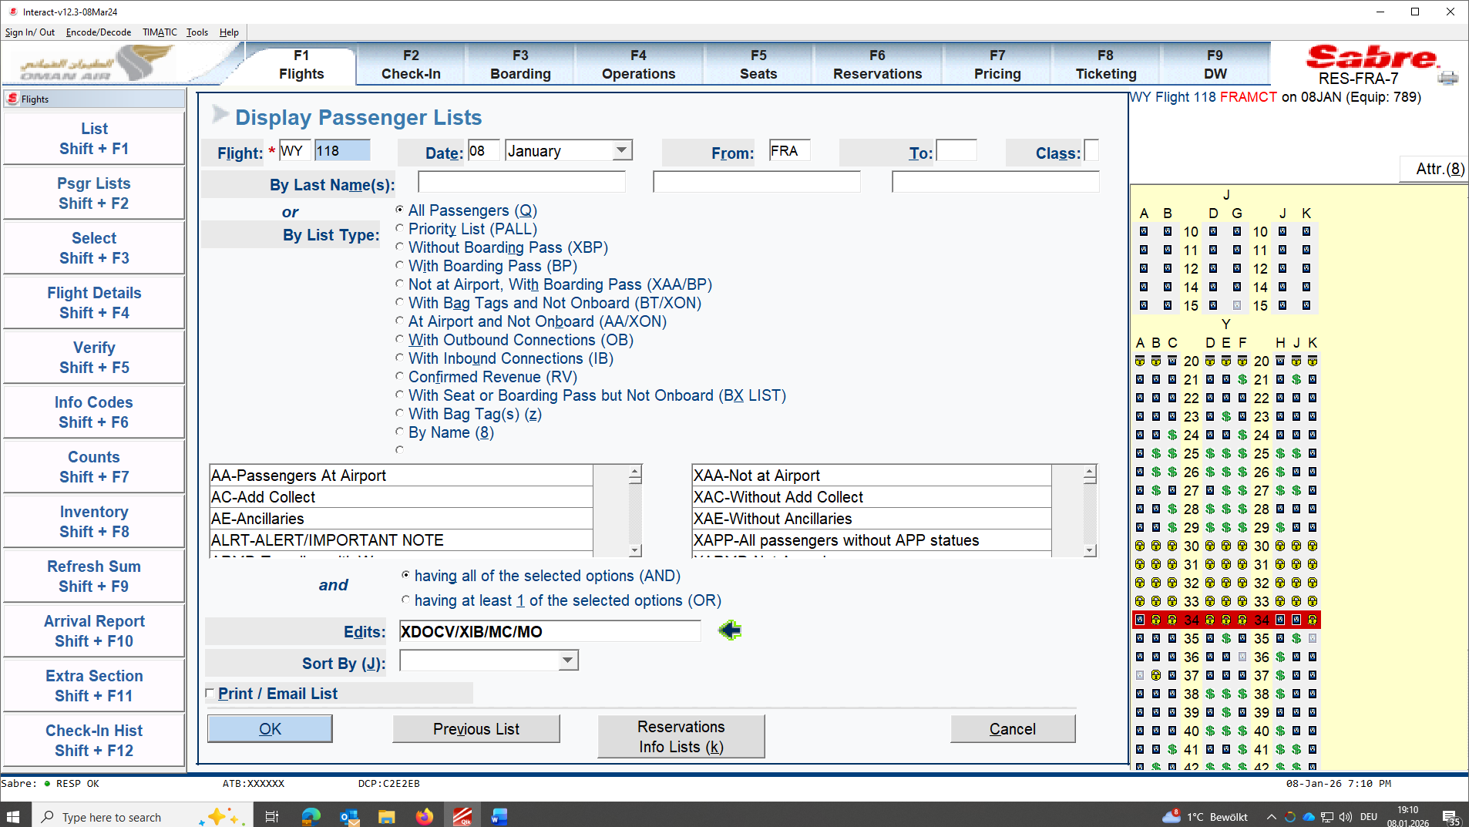

Highlight everyone on list and CM
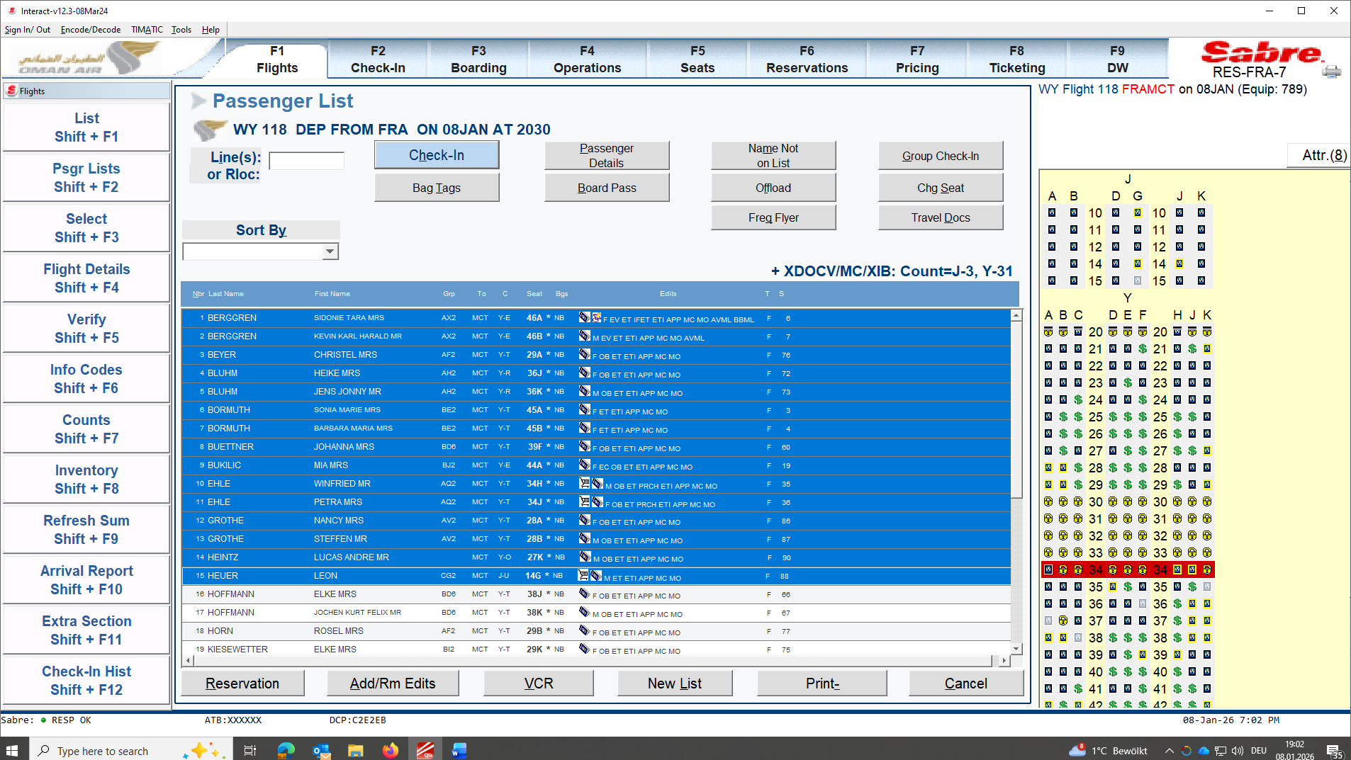

Edit: CM
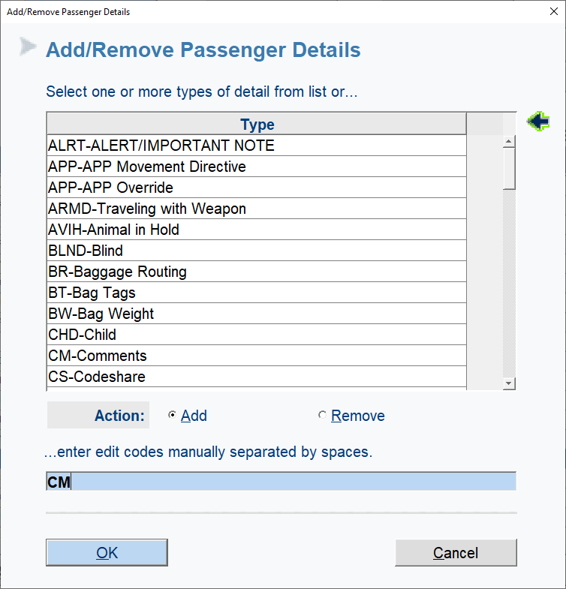

Enter CM with following information unless you are told otherwise and OK

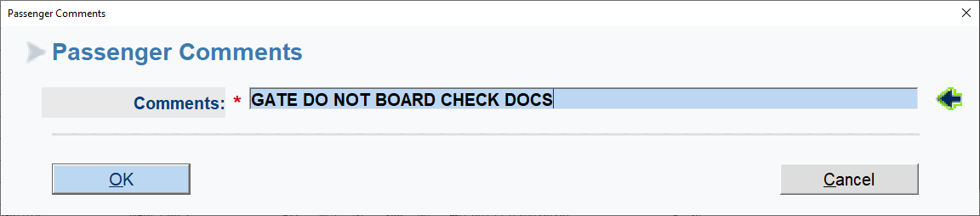

!!! IF GUEST COMES TO CHECKIN HAVING THIS CM PLEASE DELETE AFTERWARDS CHECKING GUESTS DOCUMENTS AS THIS WILL NOT LET YOU BOARD GUEST AT BOARDING POINT.

Once confirmed all guests have been Boarded coordinate counts to Loadcontroller.

Finalize flight: F4
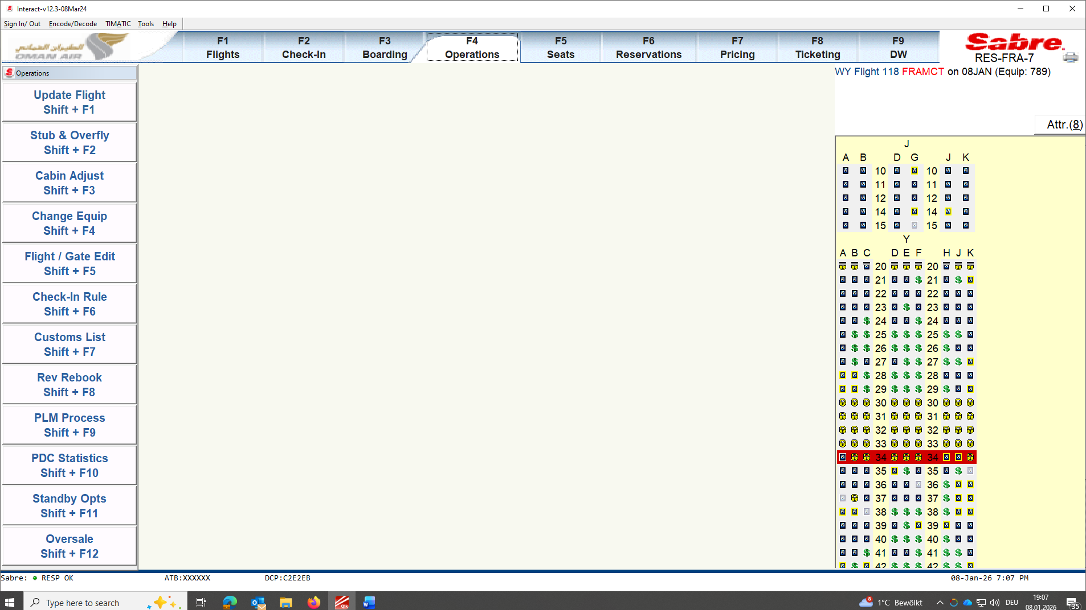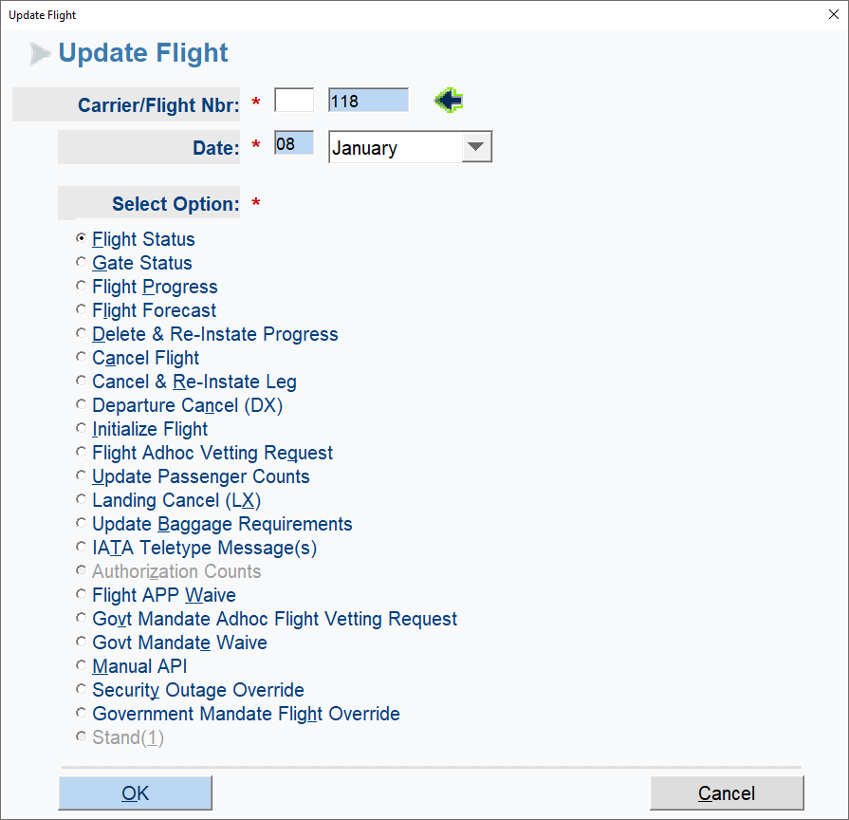
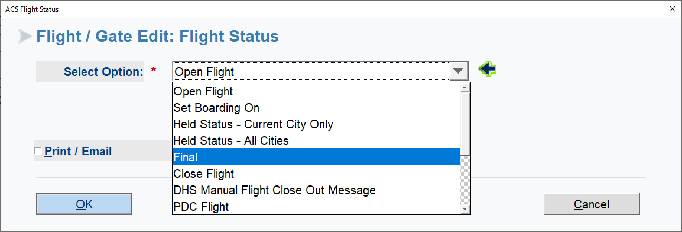

CLICK on FINAL and OK
Print out GPBL for WY REP Separate and CREW LIST to be handed over to WY REP.
GPBL Print out Boarding
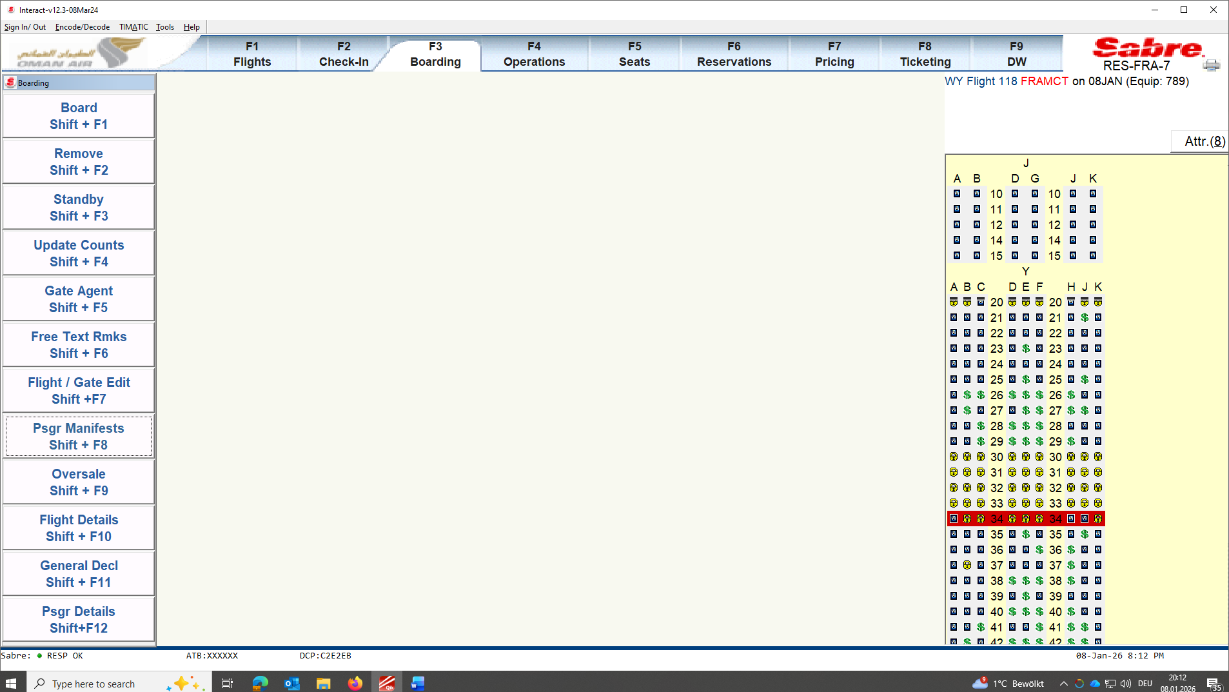

1 GHA will be following last Guest to Aircraft door to confirm with WY REP last Guest boarded unless told otherwise.

!!! After flight departure Flight closed
F4
Update Flight + F1
Ok
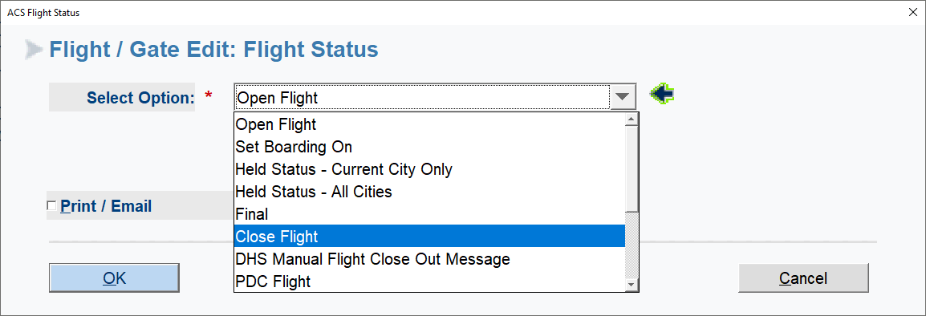
Close Flight OK.

OFFLOADING GUESTS:
Click on offload
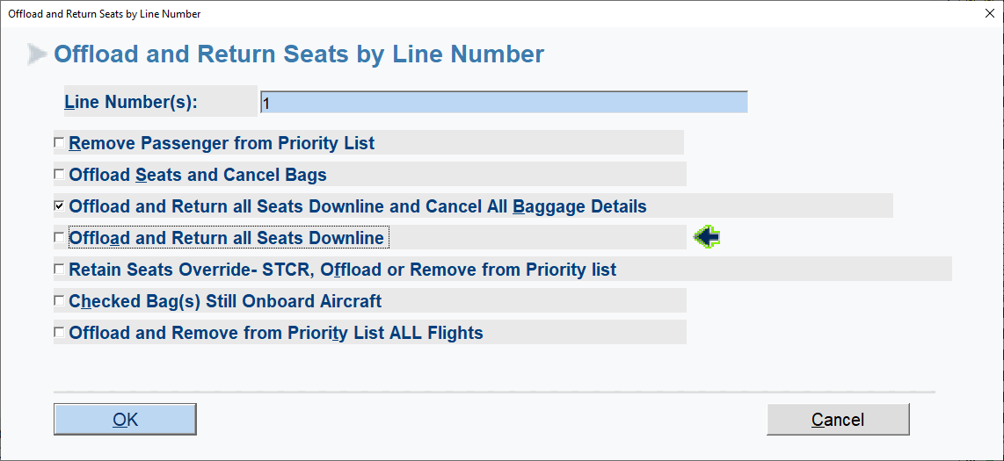

Click on
Options depending on passenger situation stated.
MPR
Recall Guests click on EDIT and add MPR
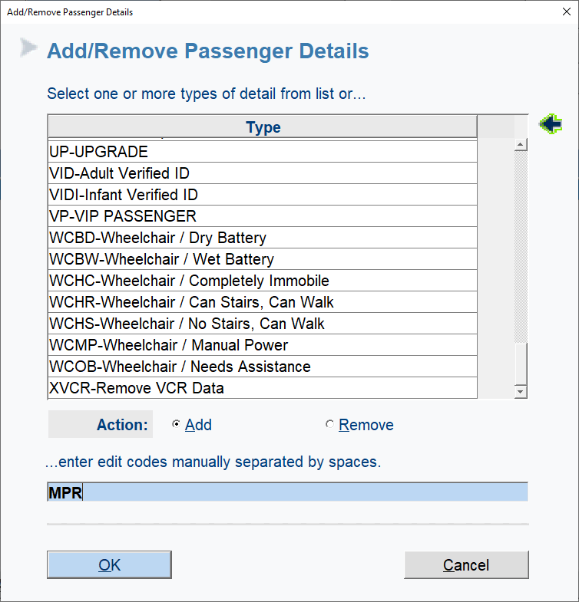

Go to Boarding
Click on Passenger manifests shift +F8
Others enter MPR
Email / Print options
Select Print then OK
Hand over to WY REP
As soon as bag has been located small sticker will be sticked on MPR to cross check the located bag matches date on MPR
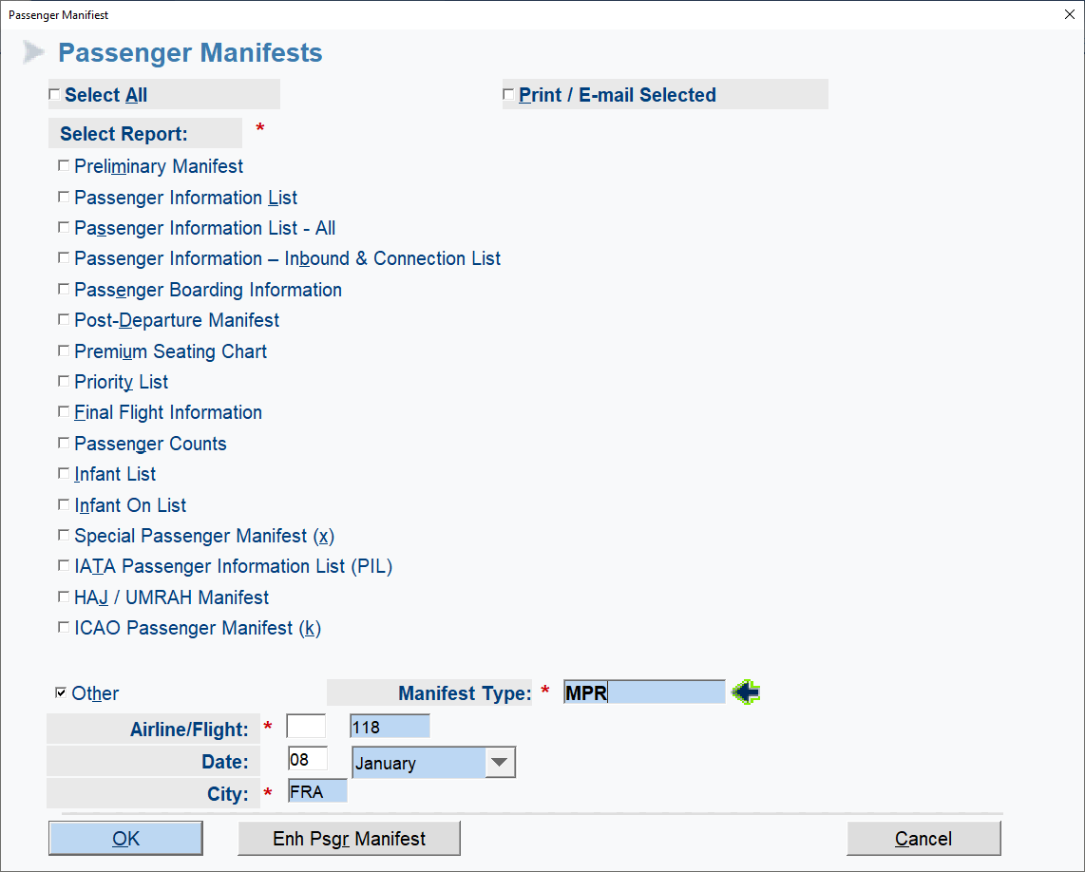

Accepting PSTC (STAFF STANDBY )
Click On F1
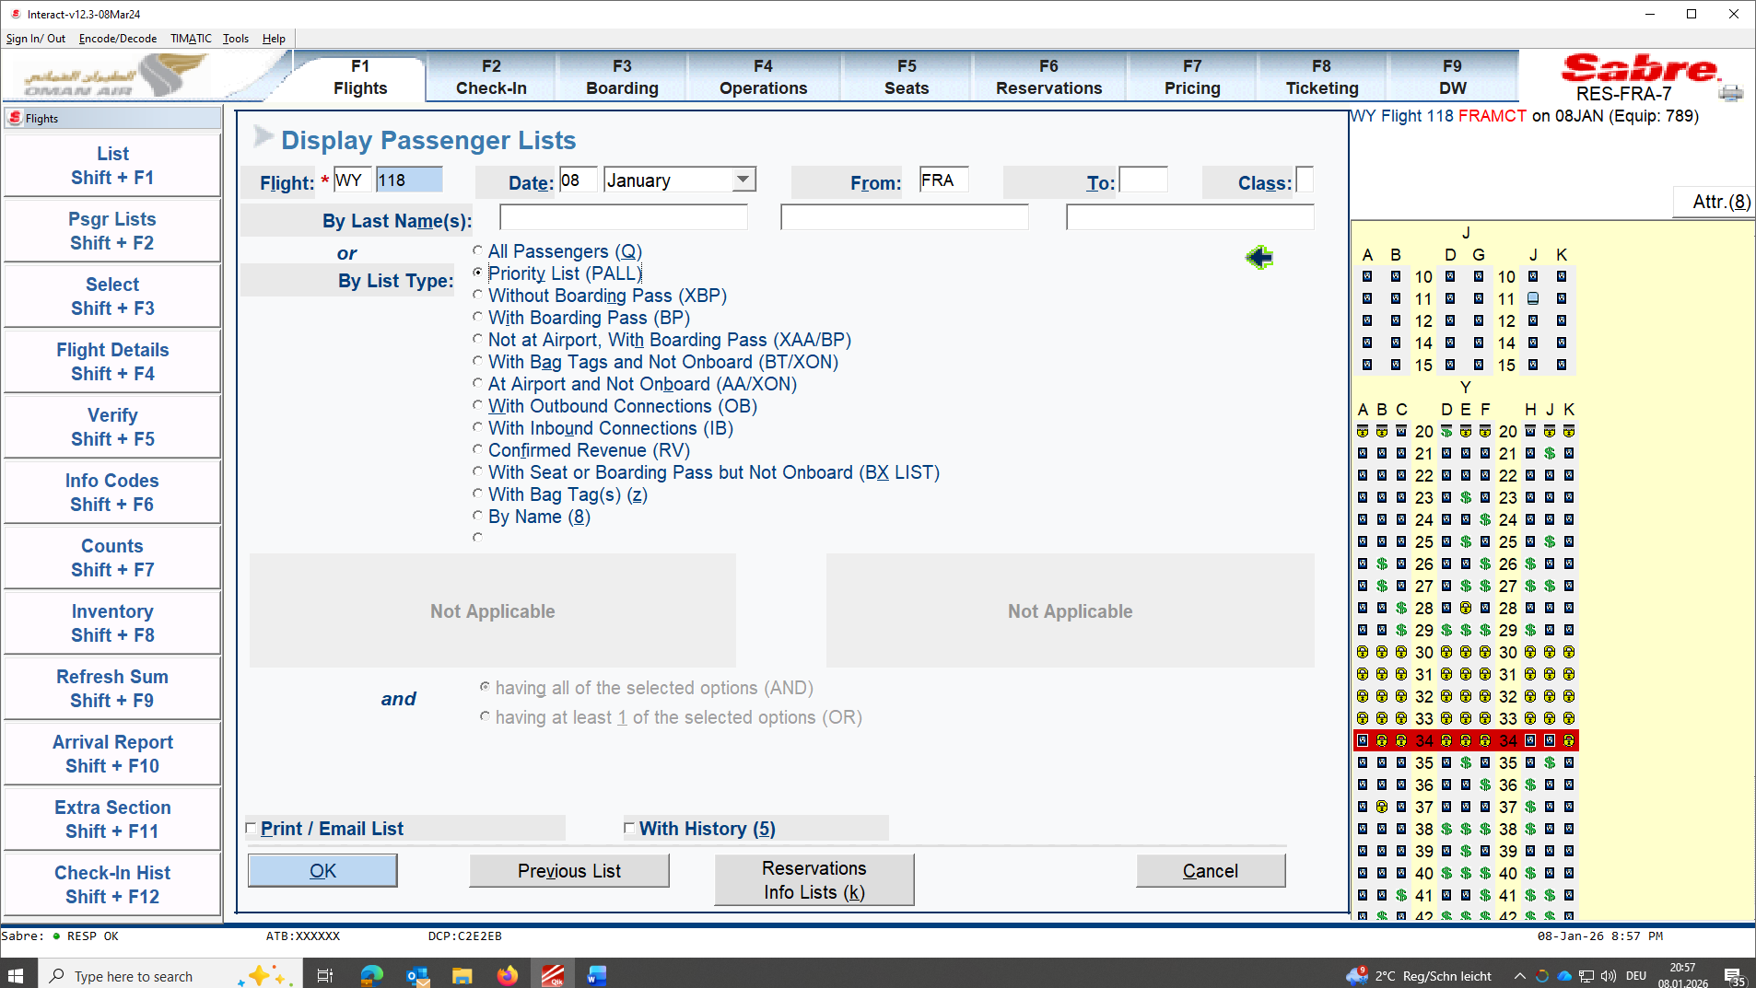
Click on Priority list (PALL) OK
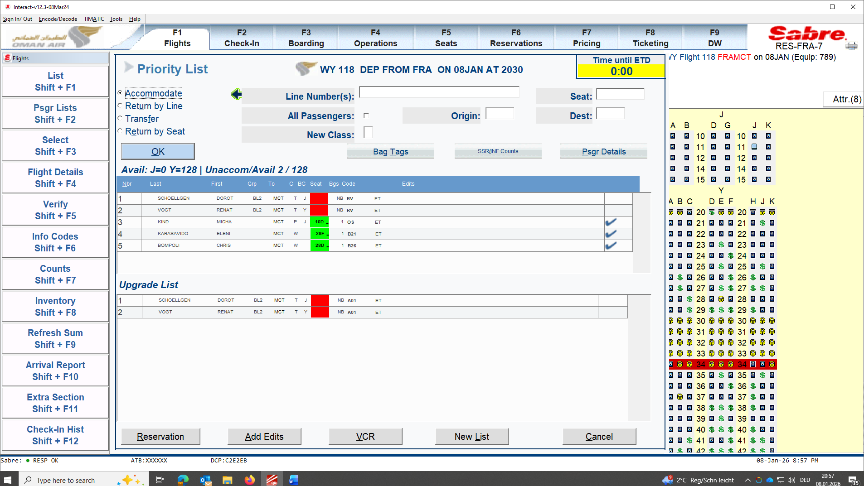
Click on Guest and accommodate according to WY REP.

!!! XON TO be crossed check with boarding agent.
Always cross check if missing passengers are
in security
any contact details to confirm if guests has booked and is planning to fly
if missing companion is flying
if missing passenger has bags to be deleted in BRS
if any bags are listed in on hand but not listed on name of Guest in SABRE specially for IB Guests.
if any rush bags needs to be given clearance

!!! We accept all mobile also from different INBOUND FLIGHTS ( LH; AC, LO ETC) and printed out boarding cards.

CODES useful to know can be searched in EDITS-
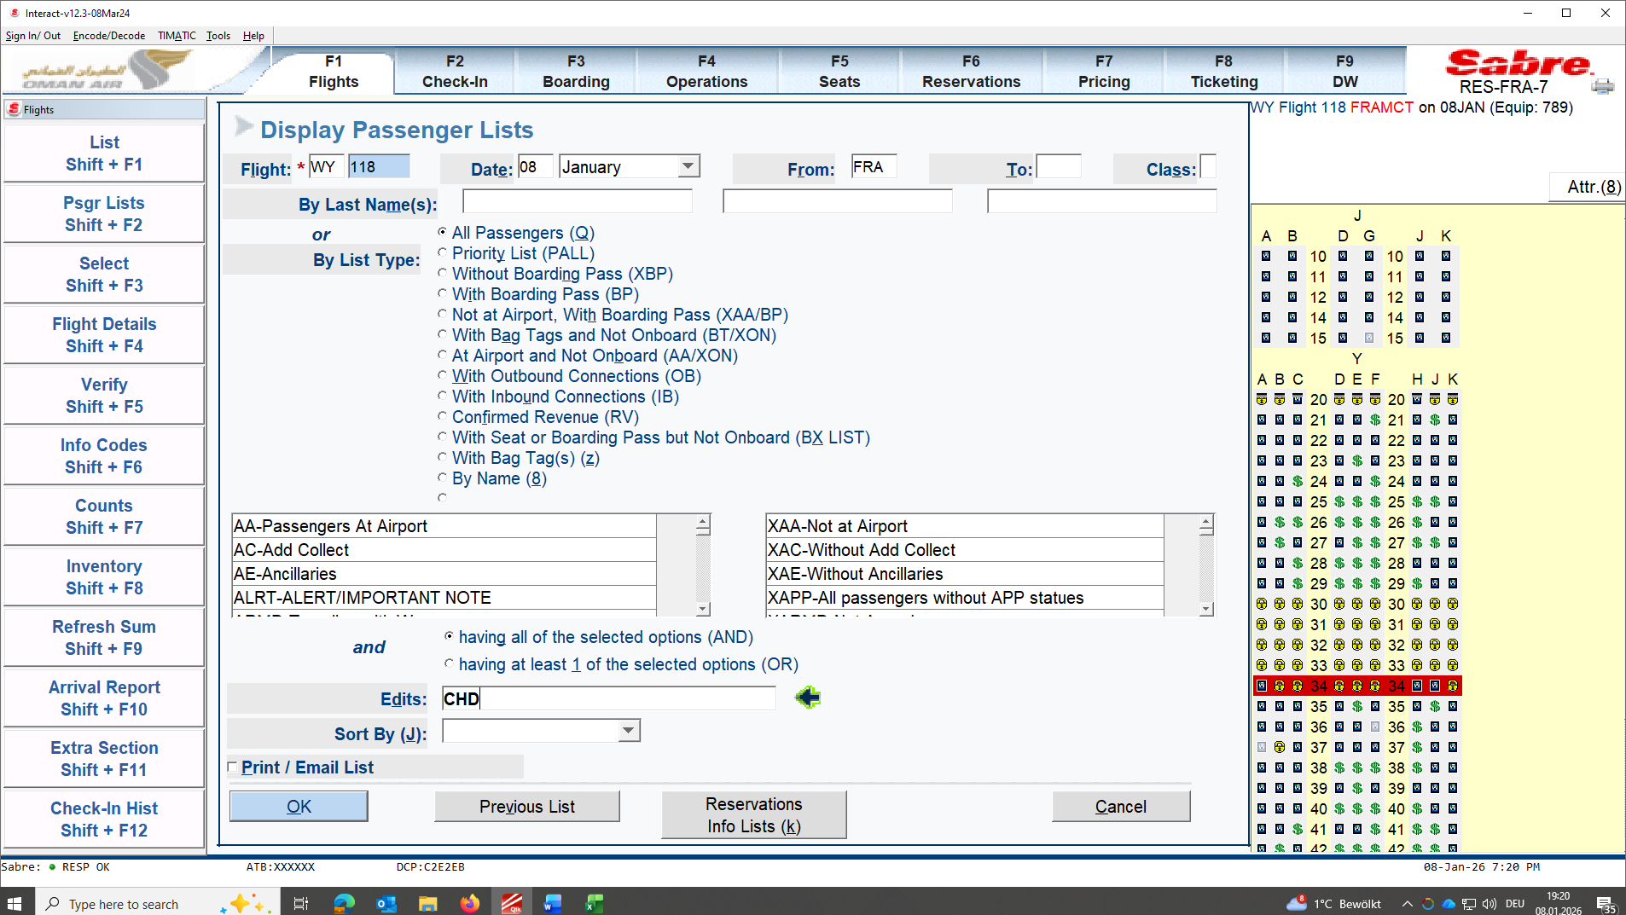
INF/IFET: Infant with E ticket
CHD: Child
UM: Unaccompanied Minor assisted by FRACARES also on WY 117 INbound
XETI: Guests with Ticket issues (need to be clarified with WY REP during briefing).
CM: Comments
CKIN: Check-in highlight as Guest has important CM or OTHERS
WCHR: Wheelchair check if R, S or C. WY Rep needs to double check condition of WCHC.
AVIH: will always be mentioned during Briefing NO PETC
IB: Inbound
OB: Outbound
PCD:
NFST: Neighbor free seat will be availed only ONLINE.
SM: Special Meal (SFML, DBML, AVML,HNML ETC). Can only be availed online 3 days prior flight.
MPR: Missing Passenger Report needs to be printed out handed out to WY REP. bag needs to located and bagtag from located bag needs to be attached on MPR.
FQTV: Frequent Traveler. ONLY follow what is stated in Sabre system. We accept expired FQTV card.
BR: Baggage routing to be crossed checked if ENCODE /DECODE AIRLINE ok with different airlines agreement. Guest needs to check-in online to retrieve separate boarding card and show bagtag to onto flight.
APIS: Advance passenger Information system

Refugee Passport: Needs to be cross checked with WY REP
Damaged Passport needs to be crossed checked with WY REP

We do have crew change on every flight:
ETA of outbound Crew will be at check-in before 19:00
Label each bag and hand over bagtag to crew one by one.

PRINTING CREW TAG or RUSH TAG
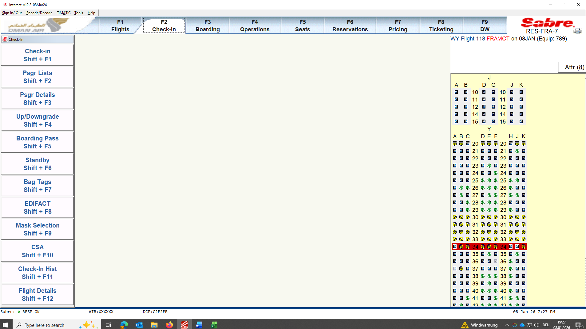
F2
Baggage Tag Shift + F7
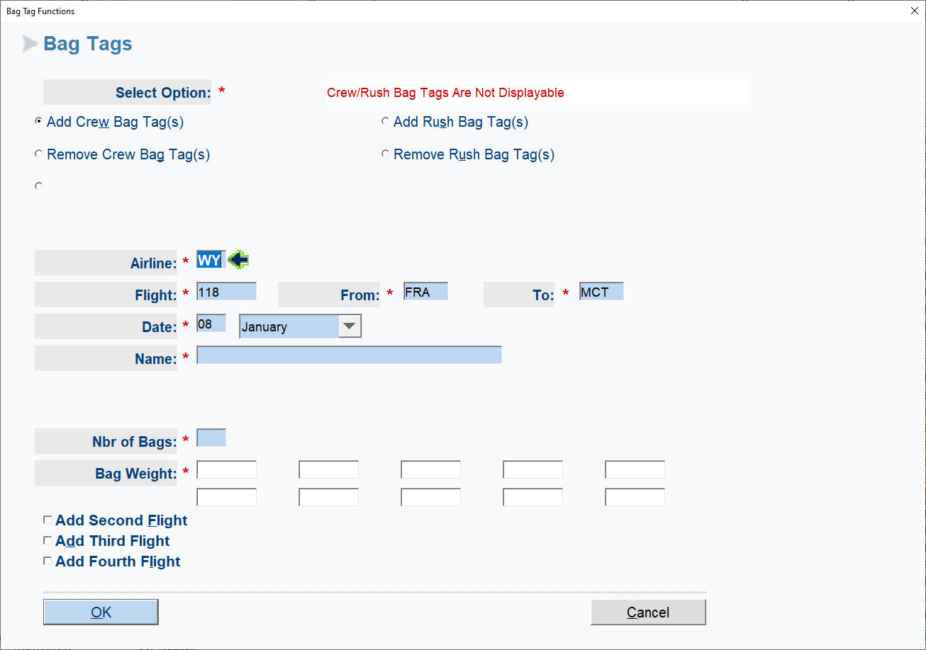
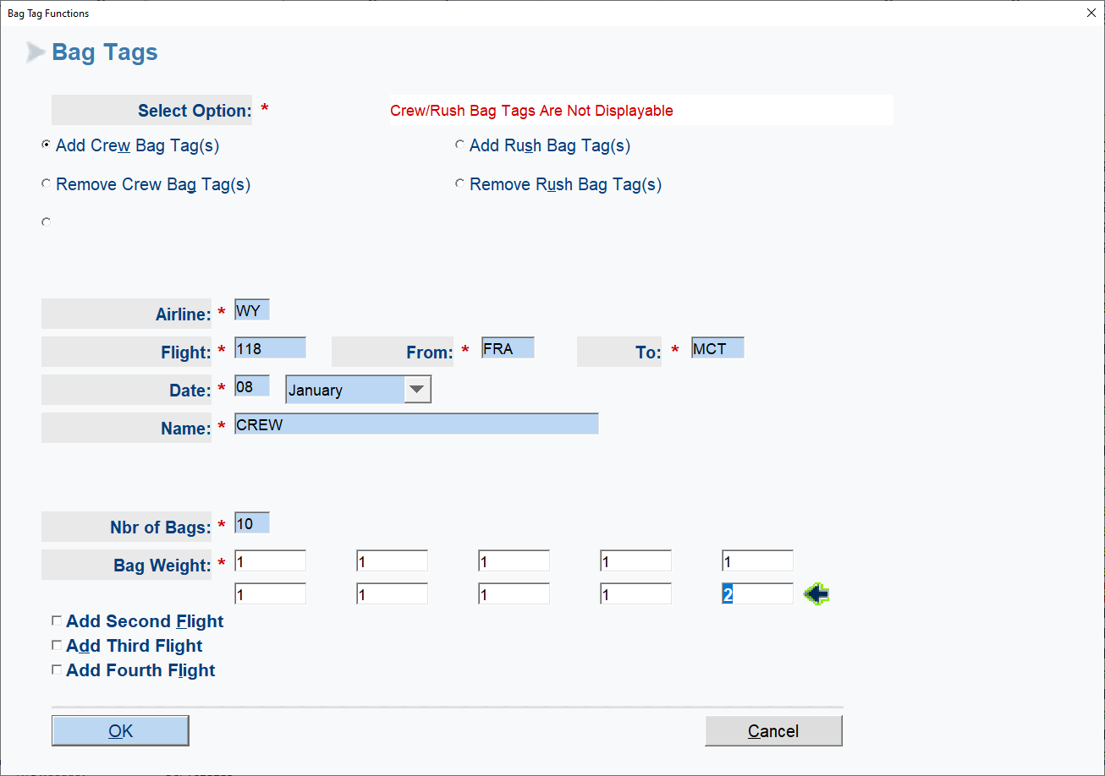

REMOVE CREW TAG
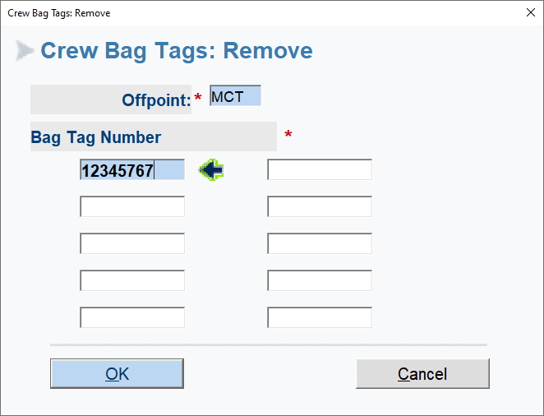

We DO NOT ACCEPT BAGGAGE POOLING KGS in separate booking!!!
Always put in CM !!! every details matters after flight departs.

Baggage Routing:
Select Guest click ok
Go to ADD RM/EDITS
BR
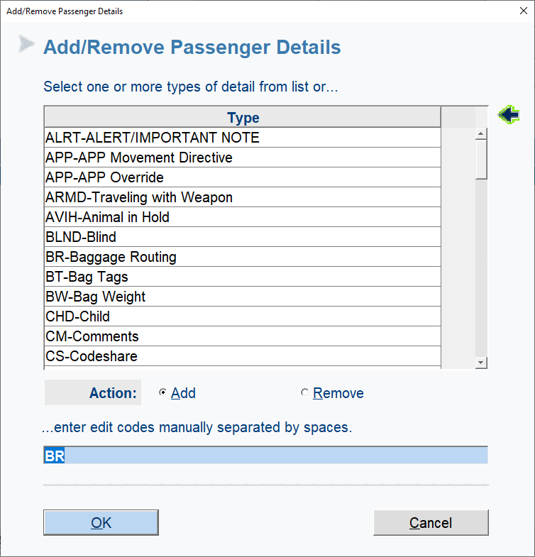
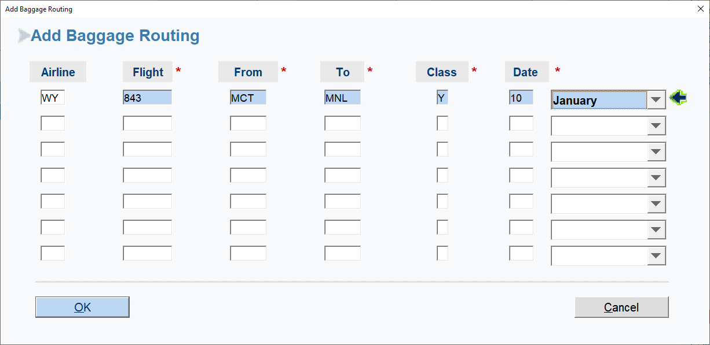

Guest needs to check-in online or in transit to collect boarding pass and cross check bagtag into onto flight.

