DHS NEWSPAPER
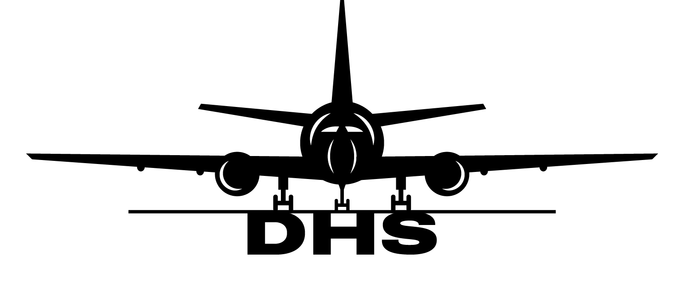
WEEKLY 23 STATION: FRA

EU LISA? EES?
GoNow has been updated with the functionality to check entry and exit authorization to and from the EU. On non-Schengen flights, document verification remains a requirement. If you encounter an error, you must not override without supervisor approval. First forward a picture of the error message to the supervisor on duty and they will troubleshoot the error. Only when entry/exit requirements are met may the supervisor override the error by following the guide uploaded in AvBIS.
LRT
On Pegasus flights, limited release tags must be used for all non-standard luggage. For example, if someone checks in an IKEA bag, it must be entered into the system as an LRT. The same is true for all baby strollers and car seats. This should always be done through the system so that it will both be recorded digitally and also print onto the tag itself. Remember, if it's not a typical piece of travel luggage, LRT.

Accurate Weight
While it might be okay to lie about our weight in a dating app, it is not okay to put the incorrect baggage weight into the system. Weight and balance is a key factor in aviation safety. Inputting the incorrect weight into the could result in the aircraft being out of trim. Which may have potentially fatal consequences.
Sign Ins
Is one of your accounts locked? Sending an email to Jonathan is the official and most reliable way for action to be taken. WhatsApp or casually mentioning it in passing may cause your account to remain locked unnecessarily.
SAFETY:
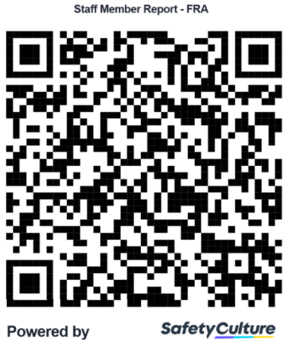
SEE SOMETHING,
SAY SOMETHING!

