DHS NEWSPAPER
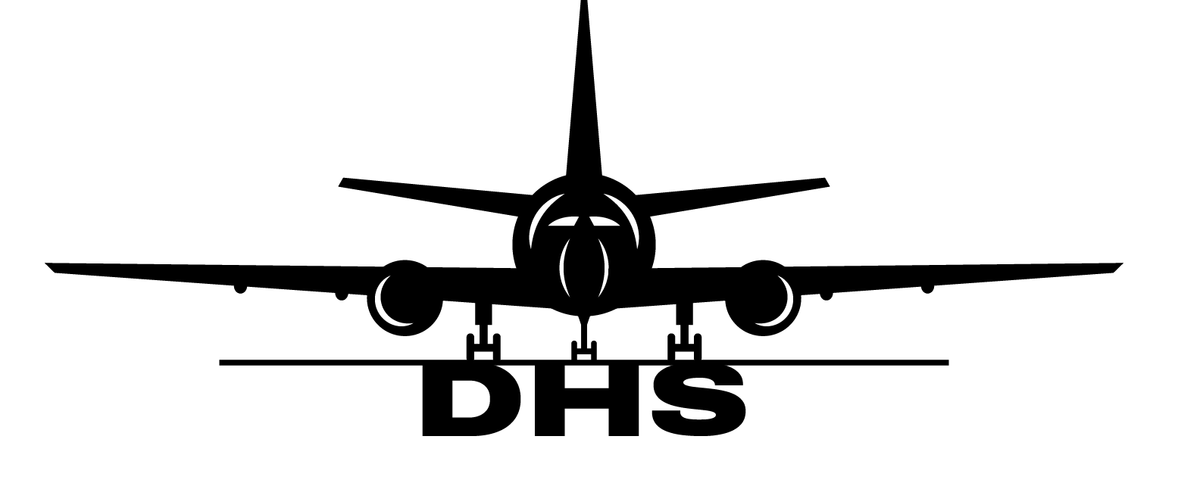
WEEKLY 1 STATION: MUC

NEW: WEEKLY NEWS TO KEEP EVERYONE UPDATED
We’re launching the DHS Newspaper to make sure everyone can access it.
… Together we keep operations running safely and efficiently.
INCIDENT HIGHLIGHT:
MEDICAL EMERGENCY AT GATE:

Paramedics were called due to a medical emergency to the gate. Gate agents continued their operations and disrupted the medical treatment.
In case something like this happens, remember:
- Passengers health is priority number 1
- Never disrupt medical or operational procedures by authorities
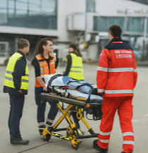

EASYJET BAGGAGES:
Please attach only one Bingo sticker to checked in baggage and leave the other one on the bagtag.

This helps to reduce
stress and delay
on the ramp.

MONTHLY OPERATIONAL STATISTICS (OCTOBER):
FLIGHTS 630
PAX 196.543
OUTBOUND PAX 92.326
SAFETY:
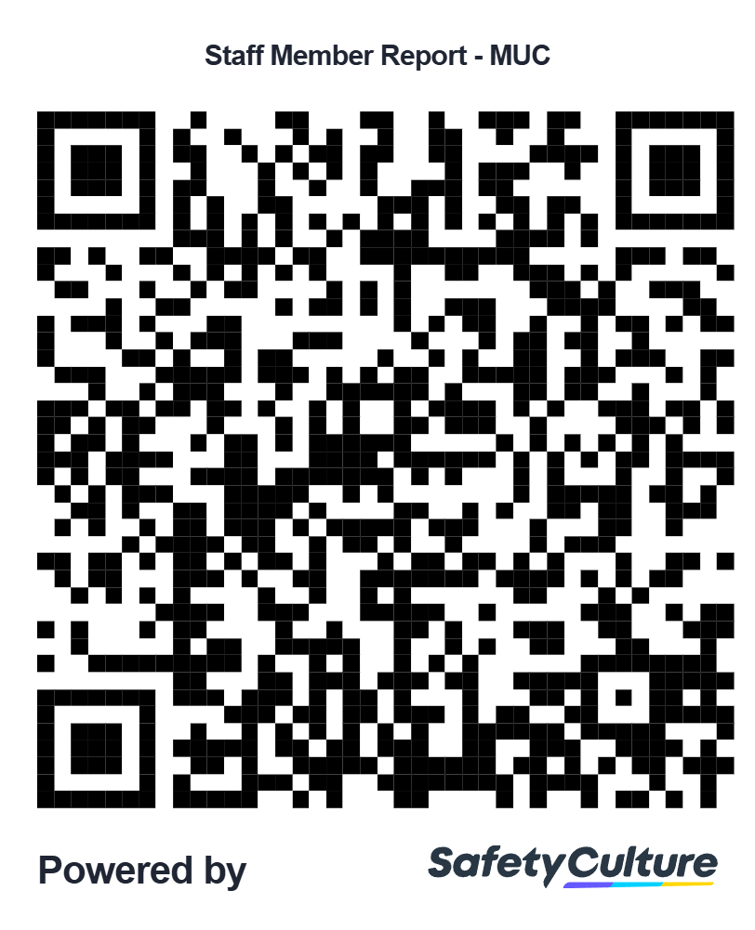

SEE SOMETHING,
SAY SOMETHING!

