Topic:
INFORMATION FOR ANIMAL TRANSPORT (AVIH)



Dear all,

The District Office of Erding has granted the animal transport authorization to all ground handling service
providers at Munich Airport. The associated additional provisions stipulate that the following information must be
carried for each animal transport and must be affixed to the respective transport containers:

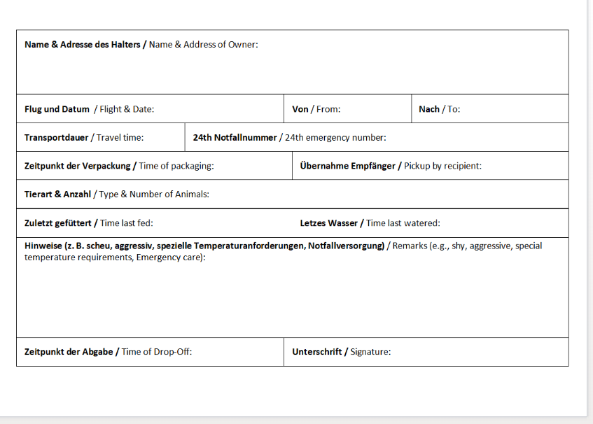
Also attached is the IATA-compliant sedation label for animals that have been medically sedated.




